

**Design Project**

**Design of an Automatic Solar Panel Debris Removing System**

**A.S.C.D.R.S**

ENGE 476 Senior Design Project II

Department of Engineering and Aviation Sciences

University of Maryland, Eastern Shore

Tochi Chukwu

Joshua Orebiyi

Project Advisor, Dr. Lei Zhang

Submitted

December 13th, 2018

List of Contents

Table of Contents

List of Contents 2

List of Figures 4

List of Tables 5

Abstract 6

1. Introduction 7

Backgound/Motivation 7

Review of Literature 9

1.1 Objective 10

1.2 Design Requirements 10

1.3 Design Constraints 10

1.4 Standards 12

1.5 Design Methods 12

2. Project Description 12

2.1 System Description 12

2.2 System Diagram 14

2.3 System Functions 15

3. Implementation Plan 15

3.1 Tasks 16

3.2 Team Organization 17

Responsibility of Tochi Chukwu. 17

Responsibility of Joshua Orebiyi. 17

3.3 Timeline/Milestones/Delivery Plan 18

4. Implementation 20

4.1 Implementation of Task 1. Conceptual Design. 20

4.2 Implementation of Task 2. Kinematic Analysis. 21

Equations of Position 21

Equations of Velocity 22

Equations of Acceleration 23

4.2.4 Matlab Verification of Kinematics analysis 25

4.3 Implementation of Task 3.Kinetic Analysis. 29

Center of Gravity 29

Force Analysis 31

Torque. 35

4.4 Implementation of Task 4. Working Model 2D. 36

4.5 Implementation of Task 5. Computer Aided Design. 39

4.6 Implementation of Task 6. FEM Stress Analysis. 42

Stress Analysis of Crank Rod 42

Stress Analysis of Conncecting Rod 46

4.7 Implementation of Task 7. Rover Re-Design. 49

4.8 Implementation of Task 8. Prototype. 51

5. Conclusion. 53

Acknowledgement 54

Appendix 55

A. Component Specs for Machine 55

1. Specs of Arduino 101 55

2. Specs of Adafruit Motor Shield 56

3. Specs of Right Angle Motor 57

4. Specs of Hobby Servos 57

5. Specs for Voltage Regulator 58

6. Specs for Switch 58

7. Specs for Fuse 59

8. Specs for Lipo Battery 59

9. Hardware 59

B. Source Code. 60

1. Arduino Source Code of Rover 60

2. Arduino Source Code of Crank Mechanism 66

3. MATLAB Source Code for Center of Gravity 70

4. MATLAB Source Code for Kinematic Analysis 71

REFERENCES 73

List of Figures

Table 1. Project Timeline and Delivery Plan 18

List of Tables

Abstract

Energy is one of the major issues that the world is facing in the world, the supply of energy has been one of the major problems for both urban and rural households. About 60% to 70% of the energy demand of the country is met by fuelwood and agriculture residues. Solar energy is a renewable source of energy, which has a great potential and it is radiated by the sun. Renewable energy is important to replace the using of electric energy generated by petroleum. Solar power has become a source of renewable energy and solar energy application should be enhanced. The solar PV modules are generally employed in dusty environments. The solar panel is work by allowing the light into solar cells. The more light that impact on a panel, the result more power it will be generate. Due to the upwards angle of solar panels, they are more liable to a build up the dust and bird dropping. The dirt which is not clean with just rain. This is reducing the same amount of light impact on the panel and reducing panel output. The dust gets accumulated on the front surface of the module and blocks the incident light from the sun. It reduces the power generation capacity of the module. The power output reduces as much as by 50% if the module is not cleaned for a month. The solar panel manufacturers and installers are claimed about the projected energy figures that based on the optimum performance of clean solar panel. Due to build up the dirt on solar panel, that can adversely affect the panel’s ability to meet that projected figures. So it is necessary and important to clean the solar panel in order to protect and get more power output. The cleaning system has been designed cleans the module by controlling the Arduino programming. In this report, the problem is reviewed and the method for debris removal is discussed. An automatic cleaning device is developed and features a versatile platform which travels the entitre length of a panel. The automatic machine will provide a favourable result and shows that such a system is viable. In conclusion it is found that the automatic machine cleaning is practical and can help in maintaining the solar panel efficiency also and reduce the maintenance cost.

1. Introduction

## Backgound/Motivation

A solar panel includes an array of solar cells covered by a transparent protective cover through which sunlight transmits to reach the solar cells. Solar energy is one of the most feasible sources of renewable energy but because of accumulation of: dust, soil, tree debris, sand, moss, dirt, sap, bugs, bird droppings, water spots or mold, the panel efficiency is significantly reduced by up to 25%. The purpose of this project was to design and develop the cleaning solar panels automatically to increase the efficiency and energy output from these panels. It is shown that panel efficiency may be reduced by up to 5% to 10% from build up dust particles alone. Adding in other factors such as falling leaves, bird dropping and water streaking, the efficiency of these panels can be further reduced to as much as 10 – 30%.

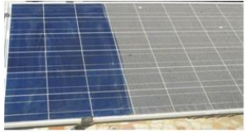

1. Solar Panel covered in Debris

Our studies show links of reduction in output. We narrowed our focus to Perdue’s solar plant. There were several considerations taken when designing the system. Firstly, in the case of commercial use, solar panels are usually placed on an angle from the ground to receive the maximum amount of sunlight. Because of this, to clean these solar panels individuals would have to climbing up on to the roof to clean the panels, which can be very hazardous or risky. The other option would be to hire a company to do it for them. The system being designed should be automatic to prevent having to climb up onto the roof or terrace and allowing for the solar panels to be cleaned by others. Another factor taken into consideration was that solar panels tend to be placed in areas where there is a lot of sunshine and very little rain. Therefore, we would not be depending upon rainfall to clean the panels, but water usage, for self-cleaning, in these areas may be limited as well. Also, there needed to be a way of determining when to clean the solar panel since having it cleaned all the time would be equally a waste of power or energy.

Additionally, we could not depend on there being a reduction of power from the panels as a method of determining when it should be cleaned since a whole cloudy day would also result in a reduction in absorption of solar rays. The accumulation of dirt on solar panels ("soiling") can have a significant impact on the performance of PV systems in regions where rainfall is limited for a dry season of several months. This effect is magnified where rainfall is absent in the peak-solar summer months, such as in California and the Southwest region of the United States. This paper describes the effects of soiling on energy production for large grid-connected systems in the US and presents a model for predicting soiling losses. The adverse impact of soiling (dust deposition) on solar collectors, and the mitigation of the related energy yield losses, are the main scopes of this paper. While soiling related losses have been studied more extensively for flat plate photovoltaic (PV) panels, this study focuses primarily on the impact of dust accumulation on concentrated photovoltaic (CPV) and concentrated solar power (CSP) systems. We report on different methods used for cleaning solar collectors: Natural cleaning by rain and snowfall, Manual cleaning by water and detergent, and an emerging method of dust removal by electrodynamic screens (EDS). Development of ED’s technology as an automated, low-cost dust removal method which does not require any water or manual labor is presented.

The automation of the system will also reduce the risk of an operator injuring himself in a high voltage environment.

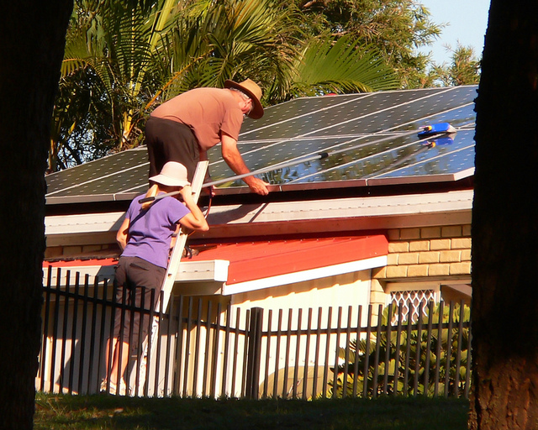

1. Safety Hazards

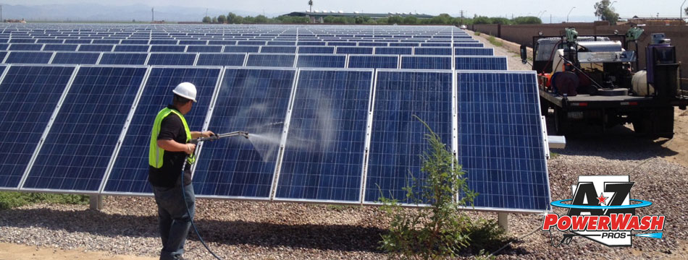

1. Manual Labor

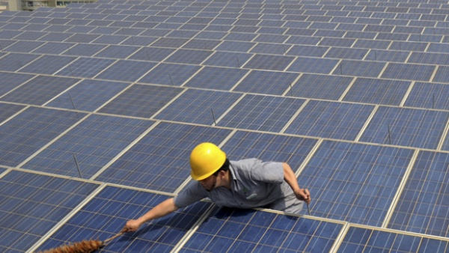

1. Unreasonable Amount of Time

## Review of Literature

The information on the effects of soiling on solar panels comes from research funded by both universities and solar energy-oriented associations. The studies that were examined all analyzed different aspects of soiling. One study, sponsored by the Power Light Corporation in Berkeley California, found a daily loss of 0.2% in power output. The report also noted a 7.5% to 12% efficiency increase due to rain 2. Another study, performed by Boston University’s Department of Electrical and Computer Engineering, observed the loss of efficiency from soiling in Lovington, New Mexico. The area had an observed 24% drop in efficiency over the course of a month. The study also found that while rain is the primary cleaning agent for panels, it is not sufficient. The Boston University Study also reported the costs and benefits of three current methods of cleaning solar panels. These methods include natural cleaning through rain and snowfall, manual cleaning, and cleaning by an electrodynamic system (EDS). In general, it was concluded that in order to maximize the cleaning effect of rain, the panels needed to have a glass shield and be oriented in the near vertical position.

Manual cleaning by water and detergent was effective; however, it required costs set aside for labor (45.7% of the total cost) and fuel (20.5% of the total cost). An emerging technology, called an EDS, consists of interdigitated electrodes (made of indium oxide) in transparent dielectric film. The cleaning process is orchestrated by low power, three phase pulsed voltages (from 5 to 20 Hz). This process led to a reflectivity restoration of 90% after only a few minutes. The University of Sonora analyzed the effect of naturally occurring dust and residue on the energy generation of solar panels. A standard ‘dirt’ layer was chosen and was tested on three types of photovoltaic cells, monocrystalline, polycrystalline, and amorphous. The maximum reduction in electric production was 6% for monocrystalline and polycrystalline and 12% for amorphous.

An IEEE study conducted by P. Burton and B. King investigated the effects of different types of dirt on solar panel efficiency. Different types and colors of dirt were tested with the emphasis on targeting dirt compositions that are found in the southwest of the United States. The study found that yellow colored dirt scattered light back into the solar panel and was less detrimental than the other dirt tested. The other three samples, all shades of red, did not perform as well. A research group at the University of Colorado studied the effect of dust on the transmission of light through glass panels. The glass panels were similar to those used on PV panels so that the study could help quantify the efficiency loss of solar panels due to soiling. The results of the study further confirmed the need of a cleaning solution for solar panels. The researchers found a 6% loss in each gram per meter squared of dust added. The effect of light transmission on the efficiency of PV panels was not included in the study--causing a hindrance in the helpfulness of the study.

## Objective

The research gathered on soiling shows that solar panels need to be properly cleaned in order to collect the maximum energy possible. Our device will boost the efficiency by increasing the energy output of solar panels in a quick and cost-effective manner and reduce maintenance cost of solar.



1. Estimated Cost Perdue Spends on Cleaning Solar field Yearly

## Design Requirements

1. The machine should capable of cleaning diverse types of debris on solar panel based on the thickness and density.
2. The operational time for the machine to effectively clean the rover should be 30 minutes per 64.6in row.
3. The whole machine frame should weigh less than 500 lbs.
4. The machine brush should be able to increase the solar panel efficiency to 80% from its initial 30% reduction.
5. The machine should be able to withstand temperature as high 85-degree Fahrenheit and as low as 25-degree Fahrenheit.
6. The motors should drive the machine with battery lasting up to 3hours.
7. The machine should only be used on a dry ground surface.

## Design Constraints

The design of the automatic machine could be limited by the cost available to design the machine, the area of work space available for the machine to move through is also a constraint. An important constraint is the maximum weight Perdue’s solar panel can handle and the stability of the solar panels structure.

* Area of work space available
  + 17’-3” 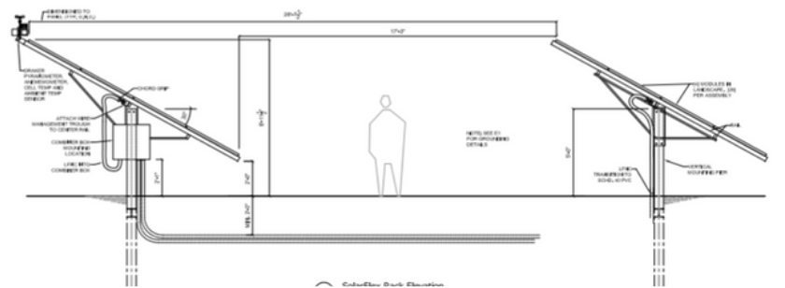

1. Work Space Available At Perdue

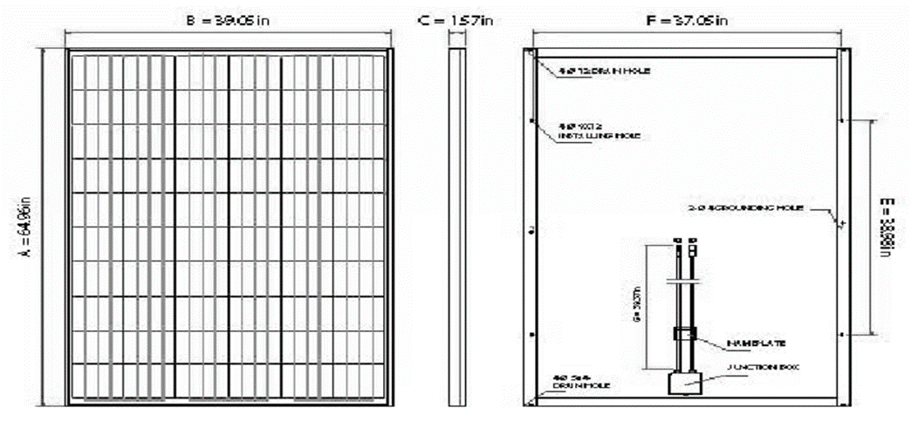

1. Geometry of Perdue’s Solar Panel

* Weight of Apparatus
  + <500lbs
* Cost (Less than $500)
* Weight of apparatus on solar panel
* Static Stability of Solar Panel Structure

## Standards

There are no standards that apply to our project.

## Design Methods

1. Design Model Chart

As shown in Figure 5, our machine design has six main steps. The first step is to design a conceptual model of the machine. The second step is to calculate the kinematic and kinetics of the machine. Once the first two steps are complete then the CAD model of the machine will be designed. The next step is to design the rover and analyze the stability. Then the prototype of the machine will be produced. The last step is the delivery of the machine to Perdue.

1. Project Description

## System Description

* Rotary and coil brushes are mounted on automated on the crank. Regardless of brush size or speed, the brush balance was implemented to ensure complete surface contact.
* Wheels here are required for the movement of the motor over the complete panel. Through this wheel, the machine will be able to move all throughout the panel.
* Motors are used for the rotational purpose of the machine. The other types of motor are being used to rotate the cleaning brushes, which helps in the cleaning purpose.

Arduino 101 is a microcontroller board based on theATmega328P. It has 14 digital input/output pins, 6 analog inputs, a 16 MHz quartz crystal, a USB connection, a power jack, etc., It contains everything needed to support the microcontroller. The role of the Arduino here is that it is been made to control the machine and working of the machine by simple programming. The Arduino 101 was used because it has a built in Bluetooth low energy and IMU.

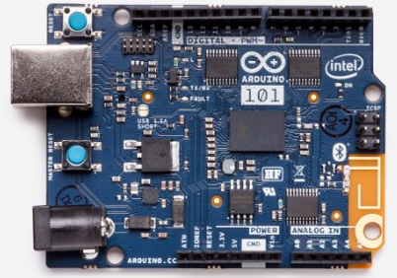

1. Arduino 101 Microprocessor

Adafruit 1438 Motor Shield v2 is the best easiest way to control DC motors servos and steppers using the Arduino 101. This shield can drive up to 4 bi-directional DC motors or 2 stepper motors. The TB6612 MOSFET driver with 1.2A per channel current capability used with the shield. The 1438 motor shield with PWM driver chip onboard handles all the motor and speed controls over I2C. This motor shield is compatible with Arduino UNOA Light Dependent Resistor is a resistor that changes in value according to the light falling on it.

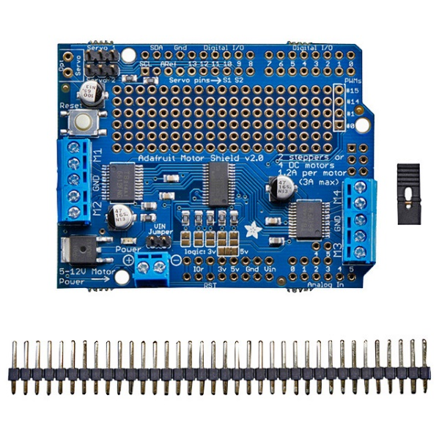

1. Adafruit 1438 Motor Shield v2

## System Diagram

The algorithm for implementation of cleaning arrangement and machine mechanism has been explained by the following flow charts.

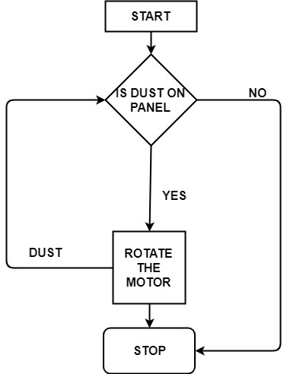

1. System Algorithm

After the dust is cleared, the rotation of the motor will be stopped. Hence the cleaning operation will be completed. The next algorithm is the machine mechanism, Initially, the robot stationed at the panel end waits the user start command. Once the command is received, the brushes start working and then the machine starts moving in one direction while cleaning the panel. During the operation, the machine keeps moving at constant speed until the sensors signal reaching the panel edge at which point the robot slows down and stops.

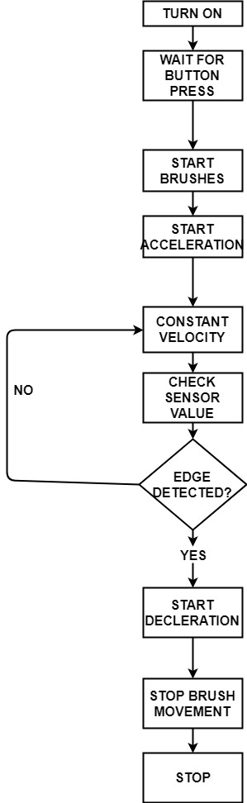

1. System Process

The crank mechanism will be controlled by two stepper motors, stepper motor driver, Arduino Uno, a bread board and most importantly an external power adapter. The Arduino Uno serves as the brain of the whole mechanism and sends information to the stepper motor driver which then makes the stepper motor rotate.

## System Functions

1. The machine will be controlled by battery
2. We will attach roller brush with soft material and roller brush rotated on the panel surface
3. After that wiper again clean the water particle which remains on the surface.
4. Implementation Plan

## Tasks

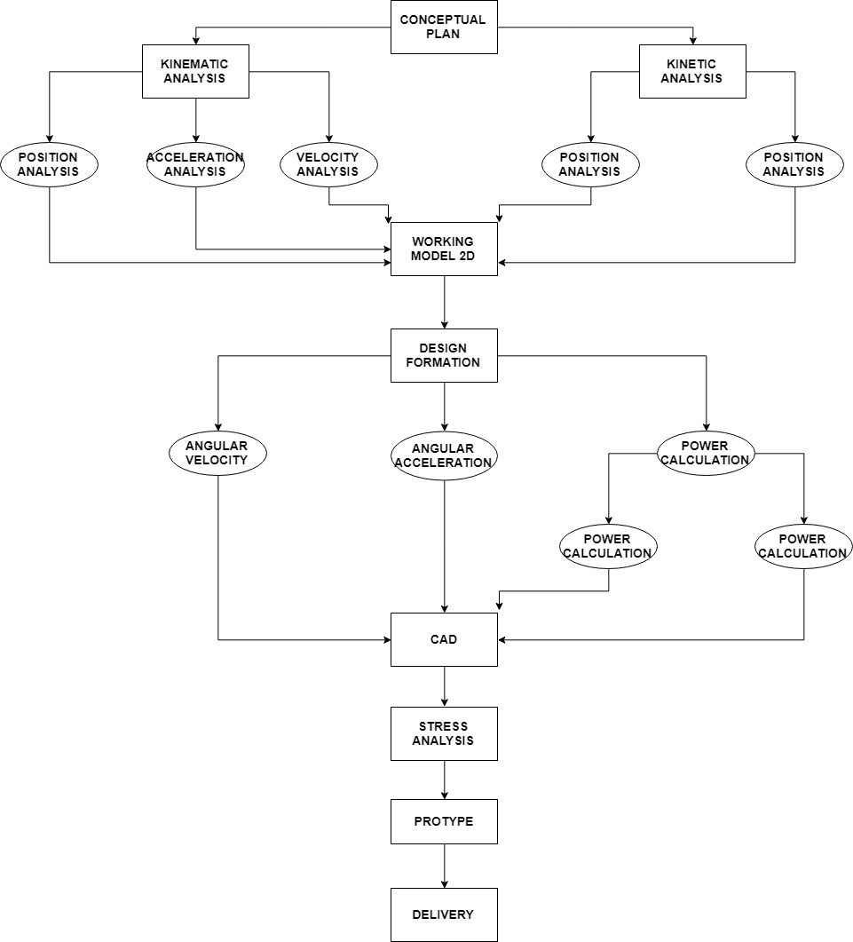

1. Implementation Task Plan

* Task 1. Conceptual Design.
* Task 2. Kinematic Analysis.
  + Subtask 2.1. Position Analysis.
  + Subtask 2.2. Velocity Analysis.
  + Subtask 2.3 Acceleration Analysis.
* Task 3. Kinetic Analysis.
  + Subtask 3.1. Force & Torque Analysis.
* Task 4. Verify Task 2 & 3 Using Working Model 2d.
* Task 5. Design Formation.
  + Subtask 5.1. Angular Velocity & Angular Acceleration.
  + Subtask 5.2. Angular Acceleration.
  + Subtask 5.3. Power Calculation.
    - Subtask 5.3.1. Select Motor.
    - Subtask 5.3.2. Select Battery.
* Task 6. Computer Aided Design.
* Task 7. Fem Stress Analysis.
* Task 8. Rover Design.
* Task 9. Prototype.
* Task 10. Delivery.

## Team Organization

## Responsibility of Tochi Chukwu.

* Task 1.
* Task 4.
* Task 5.3.1 & 5.3.2
* Task 6.
* Task 7.
* Task 8.
* Task 10.

## Responsibility of Joshua Orebiyi.

* Task 2.
* Task 3.
* Task 5. Subtask 5.1,5.2 & 5.3
* Task 6.
* Task 8.
* Task 9.
* Task 10.

## Timeline/Milestones/Delivery Plan

1. Project Timeline and Delivery Plan

|  |  |  |  |
| --- | --- | --- | --- |
| Time | Task | Comments | Responsible Personnel |
| Week 1-9 |  | Proposed different projects | Tochi Chukwu & Joshua Orebiyi |
| Week 10 | Task 1 | Design a conceptual model | Tochi Chukwu & Joshua Orebiyi |
| Week 11 | Start Subtask 2.1, 2.2 & 2.3 | Analyze the kinematics of the machine to calculate the position, velocity and acceleration analysis | Joshua Orebiyi |
| Week 12 | Cont. Subtask 2.1, 2.2 & 2.3  Start Subtask 3.1 | Analyze the kinematics of the machine to calculate the position, velocity and acceleration analysis.  Start kinetic analysis of machine | Joshua Orebiyi  Tochi Chukwu |
| Week 13 | Subtask 2.1, 2.2 & 2.3 | Continued kinematic analysis | Joshua Orebiyi & Tochi Chukwu |
| Week 14 | Finish Subtask 2.1, 2.2 & 2.3  Continued Subtask 3.1 | Finish and finalize kinematic analysis.  Continued Kinetic analysis. | Joshua Orebiyi  &  Tochi Chukwu |
| Week 15 | Start 4 | Verify completed task 2 & 3 using working model 2D. | Tochi Chukwu |
| Week 16 | Cont. Task 4 | Verify completed task 2 & 3 using working model 2D. | Tochi Chukwu |
| Week 17 | Cont. Task 4 | Verify completed task 2 & 3 using working model 2D. | Tochi Chukwu  &  Joshua Orebiyi |
| Week 18 | Finish Task 4 | Updated and completed working model 2d design. | Tochi Chukwu  &  Joshua Orebiyi |
| Week 19  &  Week 20 |  | Update Computer Aided design  &  Order machine components  &  3D print rover chassis | Tochi Chukwu  &  Joshua Orebiyi |
| Week 21 | Start subtask 5.1 & 5.2 | Start angular velocity and angular acceleration calculations. | Joshua Orebiyi |
| Week 22 | Start subtask 5.3 | Start power calculations and start research for motor and battery. | Tochi Chukwu |
| Week 23 | Finish 5.1 &  5.2  Finish subtask 5.3 | Finish angular velocity and angular acceleration calculation.  Finish & Finalize research on motor and battery. | Joshua Orebiyi  Tochi Chukwu |
| Week 24 | Task 6 | Final updates to computer aided design | Tochi Chukwu  &  Joshua Orebiyi |
| Week 25 | Start Task 7 | FEM stress analysis | Tochi Chukwu  &  Joshua Orebiyi |
| Week 26 | Finish Task 7 | Verification of FEM stress analysis | Tochi Chukwu |
| Week 27 | Start Task 8 | Rover Design | Tochi Chukwu  &  Joshua Orebiyi |
| Week 28 | Task 9 | Build Prototype  &  Update Presentation Slides | Tochi Chukwu  &  Joshua Orebiyi |
| Week 29 | Finish Task 8 | Rover Design | Tochi Chukwu  &  Joshua Orebiyi |
| Week 30 | Task 9 | Build Prototype | Tochi Chukwu  &  Joshua Orebiyi |
| Week 31 | Task 9 | Build Prototype | Tochi Chukwu  &  Joshua Orebiyi |
| Week 32 | Task 10  Work on report | Finish all documentations and report for presentation. | Tochi Chukwu & Joshua Orebiyi |

1. Implementation

## Implementation of Task 1. Conceptual Design.

According to Dr. Payam Matin, one of the team’s mechanical engineering advisors, before were able to start the design of the system we needed to see if our idea was practical. After receiving the blueprints for Perdue’s Solar field, we had to design an apparatus that would be able to clean the entire surface of the solar panel using the given dimensions. After drawing a model of the system, we saw that there were 4 main variables that we need to design our apparatus for. The variables we had to solve for were the length of the crank rod (r2), the length of the connecting rod (r3), the distance of crank from the edge of solar panel ($Y_{0}),$ and the height of the crank off the ground ($X_{0})$. We used this variables to test different arbitrary values that would give us a set of parameters that would have the crank rod be able to spin in a full 360° motion without the crank rod making contact with the ground, without the crank rod making contact with the solar panels on each sides of the work space, without the connecting rod making contact with the solar panel, and also have the brush reach from end to end of the solar panel. Upon deriving numbers for these variables that cause all these criteria to be met they we could start the design of the apparatus.

1. Variabes and lengths

|  |  |
| --- | --- |
| Variables | Lengths (in) |
| r2 | 54 |
| r3 | 144 |
| $$Y_{0}$$ | 60 |
| $$X_{0}$$ | 76 |

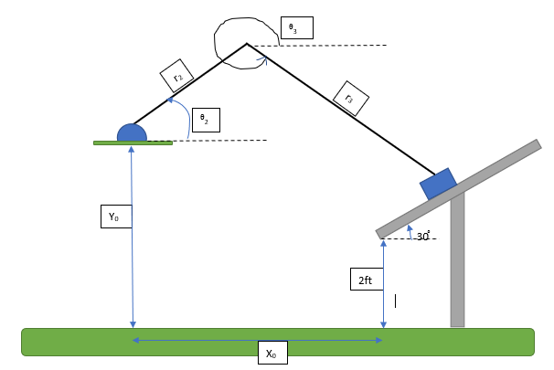

1. Diagram of Conceptual Design Variables

## Implementation of Task 2. Kinematic Analysis.

1. variable description

|  |  |  |
| --- | --- | --- |
| Variable | Description | Units |
| $$Y_{fix}$$ |  | Inches |
| $$γ$$ | Angle of the solar panel ($\frac{π}{6}$) | Radians |
| r2 | Length of crank rod | Inches |
| r3 | Length of connecting rod | Inches |
| $$(θ2- γ)$$ | Position of crank rod with respect to solar panel | Radians |
| ($θ$ 3- $γ$) | Position of connecting rod with respect to solar panel | Radians |
| $ω$ 2 | Angular velocity of crank rod | Rad/sec |
| $ω$ 3 | Angular velocity of connecting rod | Rad/sec |
| $α$ 2 | Angular acceleration of crank rod | Rad/s^2 |
| $α$ 3 | Angular acceleration of connecting rod | Rad/s^2 |

## Equations of Position

After drawing our model, we used that image to be able to determine the position of the brush by using the angle of the solar panel as the reference angle and deriving the equations in the x domain and the y domain. The equations that we started with was Equation 1.

***Position Equations***

$$γ=\frac{π}{6}$$

$$Y_{fix}\cos\left(\frac{π}{3}\right)+ r_{2}\cos\left(θ_{2}-γ\right)+ r_{3}\cos\left(θ_{3}-γ\right)=S$$

$$Y_{fix}\sin\left(\frac{π}{3}\right)+ r_{2}\sin\left(θ_{2}-γ\right)+ r_{3}\sin\left(θ_{3}-γ\right)=0$$

After deriving Equation 1 we simplify our equation in terms of ($θ$ 3- $γ$) because the motor would be added to the end of the crank rod. So, you take one equation solve for ($θ$ 3- $γ$) and substitute that into the other equation to get position in terms of ($θ$ 2- $γ$).

***Solve for $\left(θ_{3}-γ\right)$***

$${ r_{3}\sin\left(θ_{3}-γ\right)={-Y}_{fix}\sin{\frac{π}{3}}-r_{2}sin\left(θ_{2}-γ\right) }$$

$${ \frac{r_{3}sin\left(θ_{3}-γ\right)}{r_{3}}{=\frac{{-Y}_{fix}\sin{\frac{π}{3}}-r_{2}sin\left(θ_{2}-γ\right)}{r_{3}} }}$$

$$\left(θ_{3}-γ\right)=\sin^{-1}\left(\frac{{-Y}_{fix}\sin{\frac{π}{3}}-r_{2}sin\left(θ_{2}-γ\right)}{r_{3}}\right)$$

***Substitute $\left(θ_{3}-γ\right)$***

$$Y_{fix}\cos\left(\frac{π}{3}\right)+ r_{2}\cos\left(θ_{2}-γ\right)+ r_{3}\cos\left(θ_{3}-γ\right)=S$$

$$Y_{fix}\cos\left(\frac{π}{3}\right)+ r_{2}\cos\left(θ_{2}-γ\right)+ r_{3}\cos\left(\sin^{-1}\left(\frac{{-Y}_{fix}\sin{\frac{π}{3}}-r_{2}sin\left(θ_{2}-γ\right)}{r_{3}}\right)\right)=S$$

Now the equation is in terms of ($θ$ 2- $γ$) and can be solved for the position of the brush by just knowing the angle of the crank rod.

## Equations of Velocity

To be able to determine the velocity of the brush we had to take the derivative of Equation 1 to give us Equation 2.

***Velocity (derivative of position)***

$$γ=\frac{π}{6}$$

$$Y_{fix}\cos\left(\frac{π}{3}\right)+ r_{2}\cos\left(θ_{2}-γ\right)+ r_{3}\cos\left(θ_{3}-γ\right)=S$$

$$\frac{d}{dt}[Y_{fix}\cos\left(\frac{π}{3}\right)+ r_{2}\cos\left(θ_{2}-γ\right)+ r_{3}\cos\left(θ_{3}-γ\right)]= \frac{d}{dt}(S)$$

$$- r_{2}ω_{2}sin\left(θ_{2}-γ\right)- r_{3}ω_{3}\sin\left(θ_{3}-γ\right)=\left(\dot{S}\right)$$

$$Y_{fix}\sin\left(\frac{π}{3}\right)+ r_{2}\sin\left(θ_{2}-γ\right)+ r_{3}\sin\left(θ_{3}-γ\right)=0$$

$$\frac{d}{dt}[Y_{fix}\sin\left(\frac{π}{3}\right)+ r_{2}\sin\left(θ_{2}-γ\right)+ r_{3}\sin\left(θ_{3}-γ\right)=\frac{d}{dt}(0)$$

$$r_{2}ω_{2}\cos\left(θ_{2}-γ\right)+ r_{3}ω_{3}\cos\left(θ_{3}-γ\right)= 0$$

After solving for velocity, the next step was to use Equation 2 to solve for $ω$ 3. We derived equation 2 we simplify our equation in terms of $ω$ 3 because the motor would be adding the crank rod. So, you take one equation solve for $ω$ 3 and substitute that into the other equation to get position in terms of $ω$ 2.

***Solve for $ω_{3}$***

$$r_{2}ω_{2}\cos\left(θ_{2}-γ\right)+ r_{3}ω_{3}\cos\left(θ_{3}-γ\right)= 0$$

$$r_{3}ω_{3}\cos\left(θ_{3}-γ\right)=- r_{2}ω_{2}\cos\left(θ_{2}-γ\right)$$

$${\frac{{r_{3}ω}_{3}cos\left(θ_{3}-γ\right)}{r_{3}cos\left(θ_{3}-γ\right)} =-\frac{ r_{2}ω_{2}\cos\left(θ_{2}-γ\right) }{r_{3}cos\left(θ_{3}-γ\right)}}$$

$$ω_{3}{ =-\frac{ r_{2}ω_{2}\cos\left(θ_{2}-γ\right) }{r_{3}cos\left(θ_{3}-γ\right)}}$$

***Substitute $ω_{3}$***

$$- r_{2}ω_{2}sin\left(θ_{2}-γ\right)+ r_{3}(\frac{ r_{2}ω_{2}\cos\left(θ_{2}-γ\right) }{r_{3}cos\left(θ_{3}-γ\right)})\sin\left(θ_{3}-γ\right)=\dot{S}$$

$$- r_{2}ω_{2}sin\left(θ_{2}-γ\right)+r_{2}ω_{2}\cos\left(θ_{2}-γ\right) (\frac{ sin\left(θ_{3}-γ\right)}{cos\left(θ_{3}-γ\right)}){=\dot{S}}$$

$$r_{2}ω_{2}[-sin\left(θ_{2}-γ\right)+\cos\left(θ_{2}-γ\right) tan\left(θ_{3}-γ\right)]{=\dot{S}}$$

Now the equation is in terms of $ω$ 2 you can solve for the velocity of the brush by just knowing the angular velocity of the crank rod.

## Equations of Acceleration

Solving for the acceleration requires taking the derivative of velocity. After solving for Equation 2 we then took the derivative of those equations to get Equation 3.

***Acceleration (derivative of Velocity)***

$$- r_{2}ω_{2}sin\left(θ_{2}-γ\right)- r_{3}ω_{3}\sin\left(θ_{3}-γ\right)=\dot{S}$$

$$\frac{d}{dt}[- r_{2}ω_{2}sin\left(θ_{2}-γ\right)- r_{3}ω_{3}\sin\left(θ_{3}-γ\right)]=\frac{d}{dt}\dot{(S)}$$

$$- r_{2}{{[ω}_{2}}^{2}cos\left(θ_{2}-γ\right)+α_{2}\sin\left(θ_{2}-γ\right)]- r_{3}{{[ω}_{3}}^{2}\cos\left(θ_{3}-γ\right)+α_{3}\sin\left(θ_{3}-γ\right) ]=\ddot{ S}$$

$$r_{2}ω_{2}\cos\left(θ_{2}-γ\right)+ r_{3}ω_{3}\cos\left(θ_{3}-γ\right)= 0$$

$${\frac{d}{dt}[r}_{2}ω_{2}\cos\left(θ_{2}-γ\right)+ r_{3}ω_{3}\cos\left(θ_{3}-γ\right)]= 0$$

$$r_{2}{{[α_{2}\cos\left(θ_{2}-γ\right)-ω}_{2}}^{2}sin\left(θ_{2}-γ\right)]+ r_{3}{{[α_{3}\cos\left(θ_{3}-γ\right)-ω}_{3}}^{2}\sin\left(θ_{3}-γ\right)]=0$$

After deriving Equation 3, we simplify that equation by assuming steady state. We assume stead state because our motor is going to be moving at a constant velocity cause the angular acceleration to be 0 in both the crank rod and the connecting rod.

***Steady State***

$α_{2}=0$***, $α_{3}=0$***

$$- r_{2}{{[ω}_{2}}^{2}cos\left(θ_{2}-γ\right)]- r_{3}{{[ω}_{3}}^{2}\cos\left(θ_{3}-γ\right) ]=\ddot{ S}$$

$$-r_{2}{{[ω}_{2}}^{2}sin\left(θ_{2}-γ\right)]- r_{3}{{[ω}_{3}}^{2}\sin\left(θ_{3}-γ\right)]=0$$

After assuming steady state, we take the equations derived and solve for ${{ ω}_{3}}^{2}$.

After deriving Equation 3 at steady state, we simplify our equation in terms of ${{ ω}_{3}}^{2}$ because the motor would be added the crank rod. This causes the acceleration of the brush to be in terms of the angular velocity of the crank rod. Then we substituted ${{ ω}_{3}}^{2}$ that into the other equation to get angular acceleration in terms of ${{ ω}_{2}}^{2}$.

***Solve for ${ω_{3}}^{2}$***

$$-r_{2}{{[ω}_{2}}^{2}sin\left(θ_{2}-γ\right)]=r_{3}{{[ω}_{3}}^{2}\sin\left(θ_{3}-γ\right)]$$

$$\frac{-r_{2}{{[ω}_{2}}^{2}sin\left(θ_{2}-γ\right)]}{r_{3}\sin\left(θ_{3}-γ\right)}=\frac{r_{3}{{[ω}_{3}}^{2}\sin\left(θ_{3}-γ\right)]}{r_{3}\sin\left(θ_{3}-γ\right)}$$

$$\frac{-r_{2}{{[ω}_{2}}^{2}sin\left(θ_{2}-γ\right)]}{r_{3}\sin\left(θ_{3}-γ\right)}={ω_{3}}^{2}$$

***Substitute ${ω_{3}}^{2}$***

$$- r_{2}{{[ω}_{2}}^{2}cos\left(θ_{2}-γ\right)]- r_{3}{{[ω}_{3}}^{2}\cos\left(θ_{3}-γ\right) ]=\ddot{ S}$$

$$- r_{2}{{[ω}_{2}}^{2}cos\left(θ_{2}-γ\right)]- r_{3}\left(\frac{-r_{2}{{[ω}_{2}}^{2}sin\left(θ_{2}-γ\right)]}{r_{3}\sin\left(θ_{3}-γ\right)}\right)\cos\left(θ_{3}-γ\right) ]=\ddot{ S}$$

$$- r_{2}{{[ω}_{2}}^{2}cos\left(θ_{2}-γ\right)]- \left(\frac{-r_{2}{{[ω}_{2}}^{2}sin\left(θ_{2}-γ\right)]}{\sin\left(θ_{3}-γ\right)}\right)\cos\left(θ_{3}-γ\right) ]=\ddot{ S}$$

$$- r_{2}{{[ω}_{2}}^{2}cos\left(θ_{2}-γ\right)]+ r_{2}{ω_{2}}^{2}sin\left(θ_{2}-γ\right)\cot\left(θ_{3}-γ\right) ]=\ddot{ S}$$

$$r_{2}{ω_{2}}^{2}[{ \sin\left(θ_{2}-γ\right)\cot\left(θ_{3}-γ\right)-cos\left(θ_{2}-γ\right) ]=\ddot{ S}}$$

Now that the equation is in terms of ${{ ω}_{2}}^{2}$ you can solve for the acceleration of the brush by just knowing the angular velocity of the crank rod by using the equation in Figure 11.

## Matlab Verification of Kinematics analysis

After verifying the equations the next step was to add the parameters and equations into MATLAB and derive the graphs of the kinematic analysis to make sure there were no discrepancies in our formulations. These graphs show how other parts of the crank slider mechanism will behave as the crank rod is oscillation. Using this code, we set all parameters in terms of time so the we can see the trends as time elapses. Since we are using MATLAB, we had to substitute a lot of the symbols used in our calculations to be able to make our code work.

Figure 15 shows the starting parameters of our code indicating the length of the crank and connecting rods (r2 and r3 respectively), the angular velocity of the crank rod (w2) which was determined by having the crank rod move at a speed of 1 radian per second, and the angle of crank rod with respect to time (TH2) with the offset of the solar panel surface (30⁰).

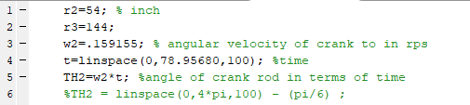

1. Parameters of code

After setting the initial parameters the next set was to input the equations that was solved for with our hand calculations. Figure 16 will give an array of values because there are multiple inputs to the equation. For this step we wrote the equation for TH3 that we derived and made a graph that was with respect to time to verify the trend of the graph. Using this code will tell you what the position of the connecting rod at any time. Also giving us a sinusoidal graph. This graph is represented in figure 17.

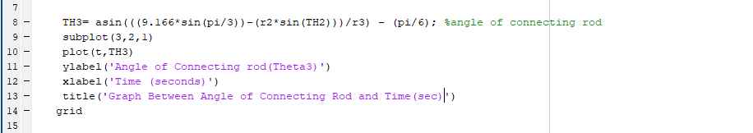

1. position of connecting rod

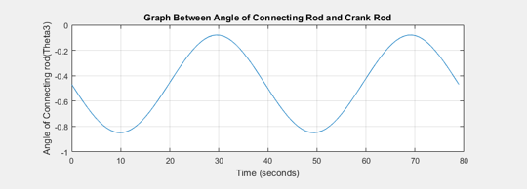

1. Position of connecting rod

Next, we input the equations for position of the brush for what was solved with the hand calculations. This is show in figure 18. In this equation we incorporate the varying values of TH2 and TH3 to give us an array of value to determine the position of the brush on the surface of the solar panel at any time. Also giving us a sinusoidal graph. The graph is represented below in figure 19.

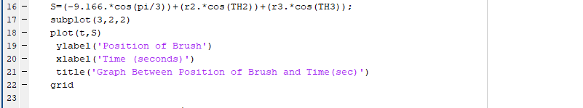

1. Position of brush

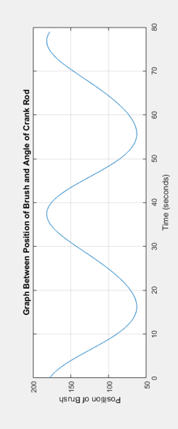

1. Position of brush

After solving the position equations, the derivatives of these equations were taken and input into the code to solve for the graphs. Figure 20 shows the input to solve for the angular velocity of the connecting rod at any time. Due to the syntax of MATLAB we replaced $ω_{3}$ with W from our hand calculations. Giving us a sinusoidal graph. The graph is represented below in figure 21.

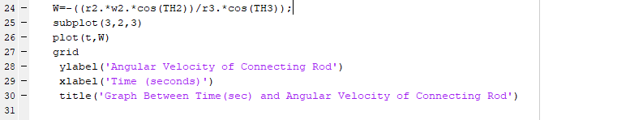

1. Angular velocity

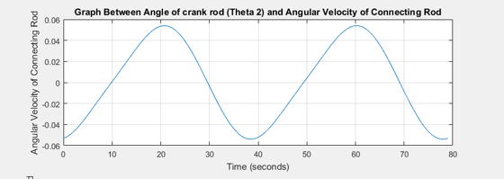

1. Angular velocity

This section of the code, figure 22, is meant to find the velocity of the brush on the surface of the solar panel. Due to the syntax of MATLAB we replaced $\dot{S}$ with Vb from our hand calculations. Using the angle of the arrays of the angle of the crank rod, the angular velocity of the connecting rod, and the angular velocity of the crank rod we are able to determine the velocity of the brush. Also giving us a sinusoidal graph. The graph is represented below in figure 23.

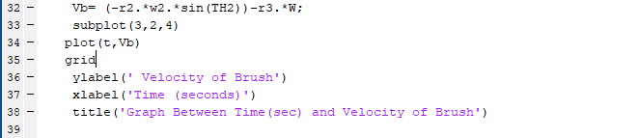

1. Velocity of brush

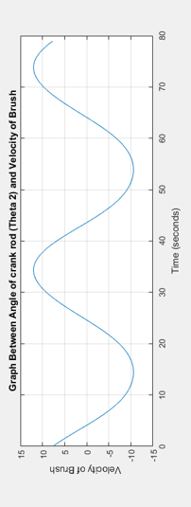

1. Velocity of brush

Furthermore, after taking the derivatives of the previous equations, velocity and angular velocity, the derivatives of these equations were taken and input into the code to solve for the new graphs. The code in figure 24 show what the angular acceleration of the cronnecting rod will be and specific points in time. Giving us a sinusoidal graph. Due to the syntax of matlab we replaced $α_{3}$ with Acc from our hand calculations. The graph is represented below in figure 25.

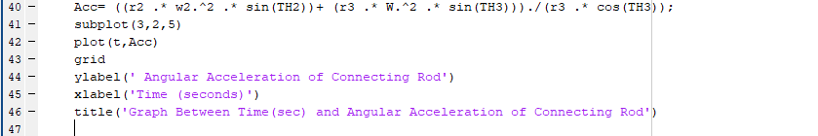

1. Angular Acceleration

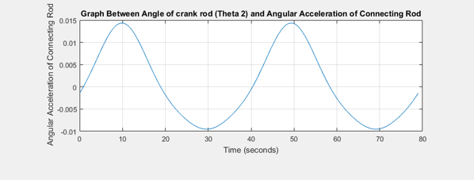

1. Angular Acceleration

This last part of the code, figure 26, uses all the parameters to be able to find the velocity of the brush and any time. These parameters include the angle of the crank rod and connecting rod, the angular velocity of the crank rod and connecting rod, and the angular acceleration of the crank rod and connecting rod. Due to the syntax of MATLAB we replaced S ̈ with AX from our hand calculations. Giving us a sinusoidal graph. The graph is represented below in figure 27.

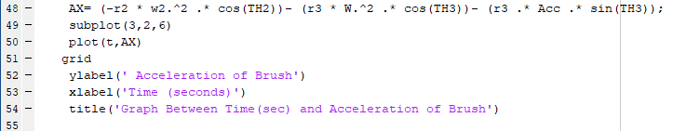

1. Acceleration of the brush

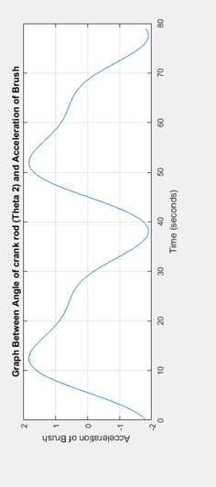

1. Acceleration of the brush

## Implementation of Task 3.Kinetic Analysis.

### Center of Gravity

When dealing with a crank slider mechanism it is important to know the forces throughout the system while treating the entire systems as a rigid body. To be able to determine the forces within the system we need to find the acceleration about the center of gravity of each element. To be able to do this we wrote a MATLAB code to be find the magnitude of acceleration about the center of gravity of each element.

In figure 30 you see the beginning part of our MATLAB code stating our initial conditions for mechanism; the length of the crank and connecting rod (r2 and r3 respectively), the angular velocity of the crank rod (w2), the magnitude of the moment arm for the crank and connecting rod (r_g1g & r_cg2 respectively), and the acceleration of the crank rod at steady state(a2).

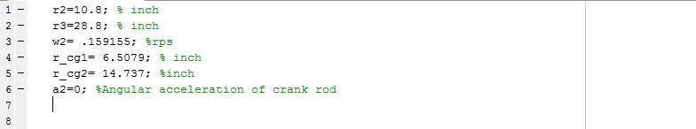

1. Center of Gravity Parameters

Figure 31 shows the MATLAB code describing the parameters of the mechanism. This code shows that the angle of the crank rod (TH2), the angle of the connecting rode (TH3), the angular velocity (W)of the connecting rod and the angular acceleration of the connecting rod (a3) are all varying/ as we you know to get the velocity of the center of gravity of the crank rod (V_cg1) you need to multiple the length from the motor to the center of gravity (r_cg1) by the angular velocity of the crank rod, which you can see in line 12. Finding this help lead us to find the acceleration in the normal direction (a_n1) and acceleration in the tangential direction(a_t1) as seen in lines 15 &16. After finding these parameters you can five the magnitude of the acceleration of gravity (ACG1). We were able to use the same formulations to be able to solve for acceleration in the normal direction (a_n2) and acceleration in the tangential direction(a_t2) for the connecting rod, the velocity of the center of gravity of the connecting rod(V_cg2) and the magnitude of acceleration of the crank rod (ACG2).

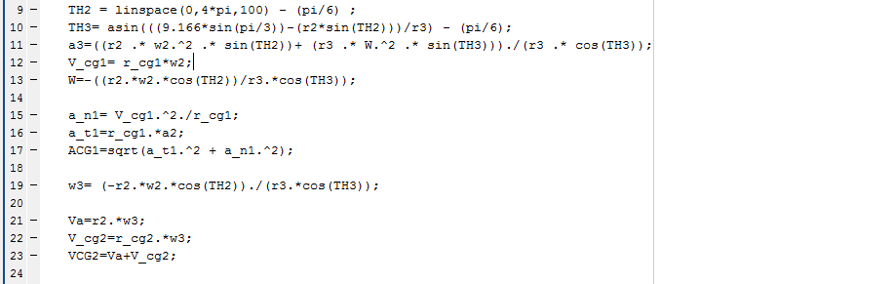

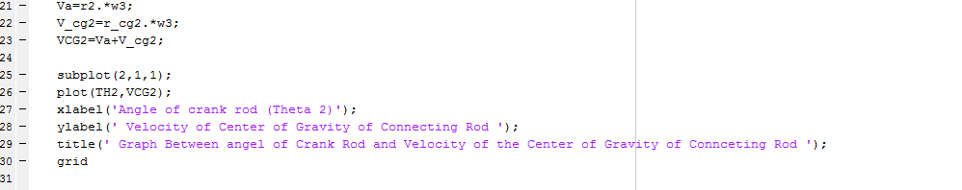

1. Velocity/Acceleration of the Center of Gravity for Crank and Connecting rod

Moving on to figure 32 we can see the graph for the relationship of where the center of gravity is for the connecting rod will be. The reason that the center of gravity will be changing is because the connecting rod is not connected directly to the motor.

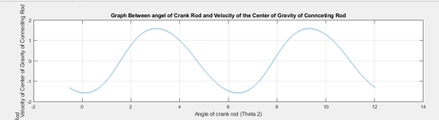

1. Relationship between angle of crank rod and Velocity **of Center of Gravity for Connecting rod**

Furthermore, figure 33 show the relationship of the acceleration of the center of gravity of the connecting rod in terms of the position of the crank rod. This irregular shape of the graph stems from the motion of the connecting rod. Since the connecting rod is not connected to the motor directly the sinusoidal pattern is different from what is to be expected.

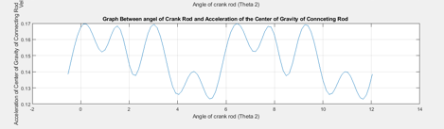

1. Relationship between angle of crank rod and Acceleration of Center of Gravity for Connecting rod

### Force Analysis

Dynamic force analysis involves the application of Newton’s three laws of motion, which are:

* A body at rest tends to remain at rest and a body in motion at constant velocity will tend to maintain that velocity unless acted upon by an external force.
* Tile time rate of change of momentum of a body is equal to the magnitude of the applied force and acts in the direction of the force.
* For every action force there is all equal and opposite reaction force.

The second law is expressed in terms of rate of change of momentum, **M** = mv, where m is mass and **v** is velocity. Mass *m* is assumed 10 be constant in this analysis. The time rate of change of *m***v** is *m*a. Where **a** is the acceleration of the mass center.

$$F=ma$$

**F** is the resultant of all forces on the system acting at the mass center.

We can differentiate between two subclasses of dynamics problems depending upon which quantities are known and which are to be found. The "forward dynamics problem" is the one in which we know everything about the external loads (forces and/or torques) being exerted on the system, and we wish to determine the accelerations. Velocities and displacements, which result from the app1ication of those forces and torques. This subclass is typical of the problems you probably encountered in an introductory dynamics course, such as determining the acceleration of a block sliding down a plane, acted upon by gravity. Given **F** and *m*, solve for **a**.

The one, which gives the most information about forces internal to the mechanism, requires only the use of Newton's law as defined in equations. These can be written as a summation of all forces and torques in the system.

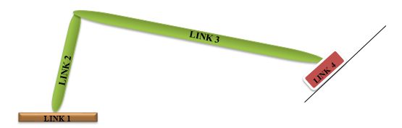

1. Crank Slider Mechanism

$$\sum{F}=ma$$

$$\sum{T}=I_{G}∝$$

It is also convenient to separately sum force components in *X* and *Y* directions. With the coordinate system chosen for convenience. The torques in our two-dimensional system are all in the Z direction. This lets us break the two vector equations into three scalar equations:

$$\sum{F_{x}}={ma}_{x}$$

$$\sum{F_{y}}={ma}_{y}$$

$$\sum{M_{z}}=I_{G}∝$$

These three equations must be written for each moving body in the system which will lead to a let of linear simultaneous equations for any system. The set of simultaneous equations can most conveniently be solved by a martial method.

The figures below will show a crank linkage. All dimensions of link lengths, link positons. Locations of the links' CGs. linear accelerations of those CGs and link angular accelerations and velocities have been previously determined from a kinematic analysis. We wish to determine the forces at the joints and the driving torque needed on the crank to provide the specified accelerations. A kinematic analysis was previously done in order to determine all position. velocity, and acceleration information for the positions being analyzed. This linkage has three moving links. Equation provides three equations for any link or rigid body in motion. We should expect to have nine equations in nine unknowns for this problem.



1. Free Body Diagram of Link 1



1. Free body Diagram of Link 2

**Equations for link 2**



$$\sum{F_{x}}=F_{12x }+ F_{32x }={m_{2}a}_{{G2}_{x}}$$

$$\sum{F_{y}}=F_{12y }+ F_{32y }={m_{2}a}_{{G2}_{y}}$$

$$\sum{M_{z}}=T_{12}+\left(R_{12x}F_{12y}-R_{12y}F_{12x}\right)+\left(R_{32x}F_{32y}-R_{32y}F_{32x}\right)=I_{G3}∝_{3}$$

1. Free Body Diagram for Link 3

**Equations for link 3**

$$\sum{F_{x}}=F_{43x }- F_{32x }={m_{3}a}_{{G3}_{x}}$$

$$\sum{F_{y}}=F_{43y }- F_{32y }={m_{3}a}_{{G3}_{y}}$$

$$\sum{M_{z}}=\left(R_{43x}F_{43y}-R_{43y}F_{43x}\right)-\left(R_{23x}F_{32y}-R_{23y}F_{32x}\right)=I_{G3}∝_{3}$$

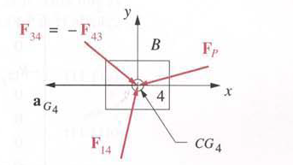

1. Free Body Diagram f**or Link 4**

**Equations for link 4**

$$\sum{F_{x}}=F_{14x }- F_{42x} + {Ff}_{x}={m_{4}a}_{{G4}_{x}}$$

$$\sum{F_{y}}=F_{14y }- F_{43y }+ {Ff}_{y}={m_{4}a}_{{G4}_{y}}$$

$$\sum{M_{z}}=\left(R_{14x}F_{14y}-R_{14y}F_{14x}\right)-\left(R_{34x}F_{43y}-R_{34y}F_{43x}\right) +(=I_{G3}∝_{3}$$

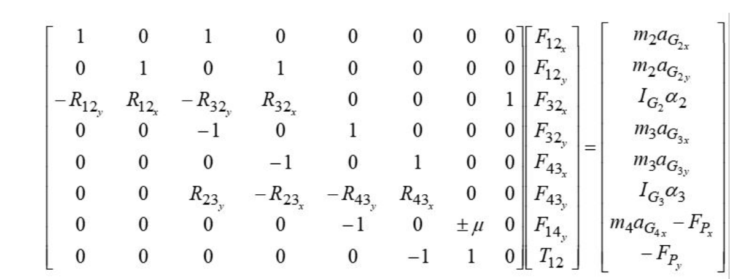

### Torque.

Torque is a quantitative measure of the tendency of a force to cause or change rotational motion. Torque (also called a moment) is the term we use when we talk about forces that act in a rotational manner. You apply a torque or moment when you turn a dial, flip a light switch, drill a hole, tighten a screw or bolt, or in this case rotate a motor. In order to effectively design with D.C. motors, it is necessary that we understood their characteristic curves. For every motor, there is a specific Torque/Speed curve and Power curve.

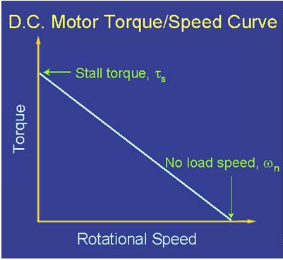

1. Torque/Speed Curve of A Typical D.C. Motor.

The graph above shows a torque/speed curve of a typical D.C. motor. Note that torque is inversely proportional to the speed of the output shaft. In other words, there is a *tradeoff* between how much torque a motor delivers, and how fast the output shaft spins. Motor characteristics are frequently given as two points on graphs:

* The stall torque,, represents the point on the graph at which the torque is a maximum, but the shaft is not rotating.
* The no load speed, is the maximum output speed of the motor (when no torque is applied to the output shaft).

The curve is then approximated by connecting these two points with a line, whose equation can be written in terms of torque or angular velocity as seen in the equations below:

$${τ_{motor}=τ}_{s}- ωτ_{s}/ω_{n}$$

$$ω_{motor}=\left(τ_{s}-τ\right)ω_{n}/τ_{s}$$

|  |
| --- |
| The linear model of a D.C. motor torque/speed curve is a very good approximation. The torque/speed curves shown below are actual gotten from the working model 2D prototype design Note that the characteristic torque/speed curve for this motor is linear.  This is generally true as long as the curve represents the direct output of the motor, or a simple gear reduced output. If the specifications are given as two points, it is safe to assume a linear curve. This linear line graph will continually accelerate in a straight line.  .   1. Working Model 2D Motor Rotation. |

## Implementation of Task 4. Working Model 2D.

Working Model (WM) is an engineering simulation software product by Design Simulation Technologies. Virtual mechanical components, such as springs, ropes, and motors are combined with objects in a 2D working space. After the software is run, the program will simulate the interaction of the model's parts and can also graph the movement and force on any element in the project. It is useful for basic physics simulations and can be quite a powerful dynamic geometric analytical tool, once you learn it. The working model simulation is used to verify the kinetic and kinematic MATLAB results.

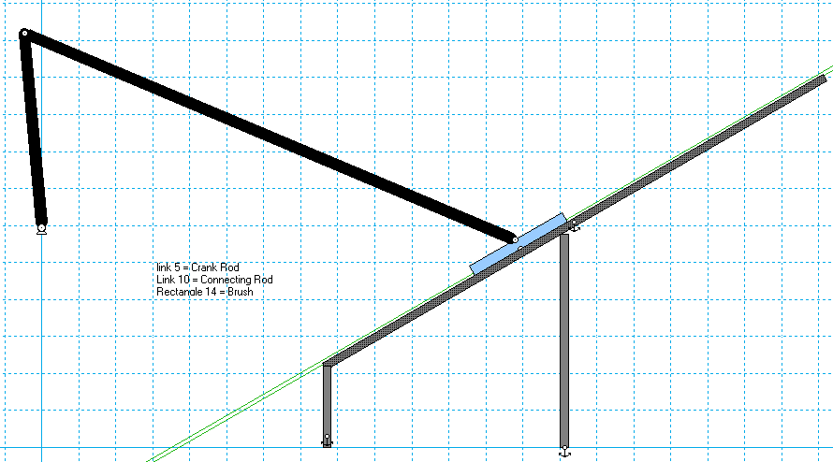

1. Design Schematic Simulation on Working Model 2D

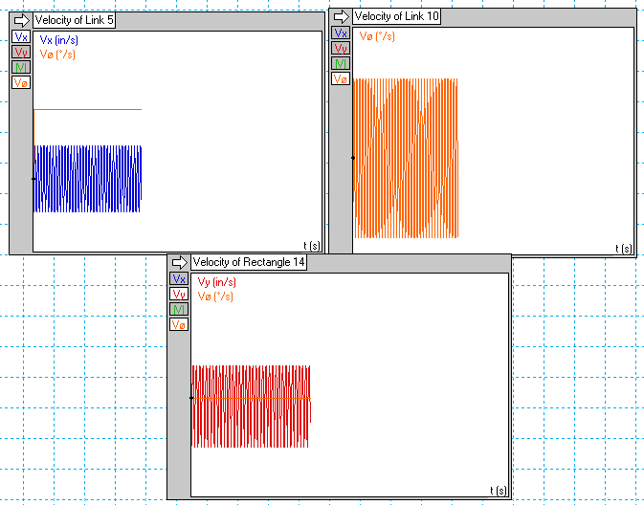

1. Working Model 2D Velocity Result

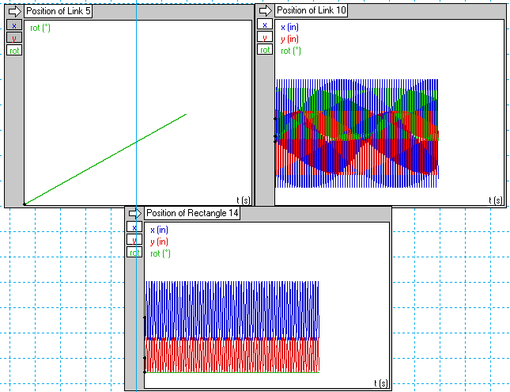

1. Working Model 2D Position Results

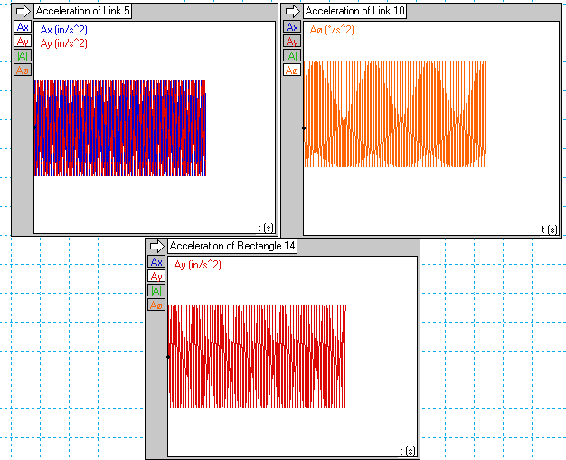

1. Working Model 2D Acceleration Results

Vx = Velocity along the x axis.

Px = Position along the x axis.

Ax = Acceleration along the x axis.

Vy = Velocity along the y axis.

Py = Position along the y axis.

Ay = Acceleration along the y axis.

|V|, |P|, |A| = The speed.

Vø = Angular velocity of the vehicle.     
Pø = Angular position of the vehicle.

Aø = Angular acceleration of the vehicle

## Implementation of Task 5. Computer Aided Design.

SolidWorks is a solid modeling computer-aided design and computer-aided engineering computer program that runs on Microsoft Windows. We used the software to design an exploded model of our machine.

At first we used solid works to design a conceptual model of our machine and this process involved an adequate amount of trial and error. In this step we used the model to determine how elongated the connecting road and crank rod needed to be to for the mechanism to properly reach the top and bottom of the solar we were also able to determine how tall the rover needed to be to enable the machine crank properly. We also had to take into consideration the work space available for the machine to rotate freely but without colliding with the solar panel behind the machine. The table below shows the dimensions of the mechanism designed on Solid works.

1. Dimensions Derived from Conceptual Model Design

|  |  |  |
| --- | --- | --- |
|  | Total Length (Inches) | Height (FT) |
| Crank Rod | 54 |  |
| Connecting Rod | 144 |  |
| Brush | 20 |  |
| Machine (top of motor to ground) |  | 5 |

More specification for the machine will be explained in the next few pages.

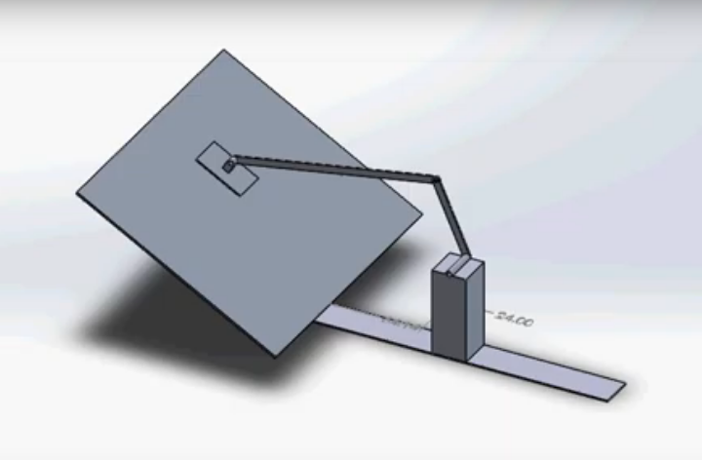

1. First Conceptual Model

Complete list of designed parts on solid works

* Crank rod
* Connecting rod
* Brush
* Brush holder
* 4 x Right angle motors
* 4 x Servos
* 4 x Rover arms
* 4 x Rover legs
* Body
* 4 x RC tires

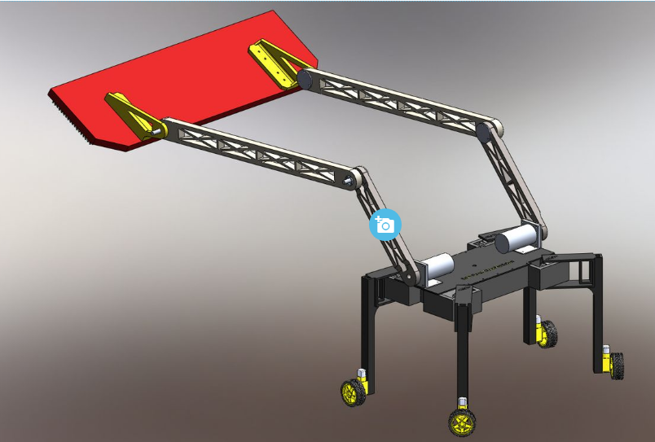

1. Exploded Model o**f Machine**

## Implementation of Task 6. FEM Stress Analysis.

Finite element analysis is a very powerful tool and one which is used extensively in engineering. It allows the solution of problems whose geometry is too complex for classical closed form methods of stress and deflection analysis. We used solid woks simulation which is an intuitive virtual testing environment for static linear, time-based motion and high-cycle fatigue simulation. With FEM analysis we were able to determine if the rods will perform properly and how long it will last during our design phase.

### Stress Analysis of Crank Rod

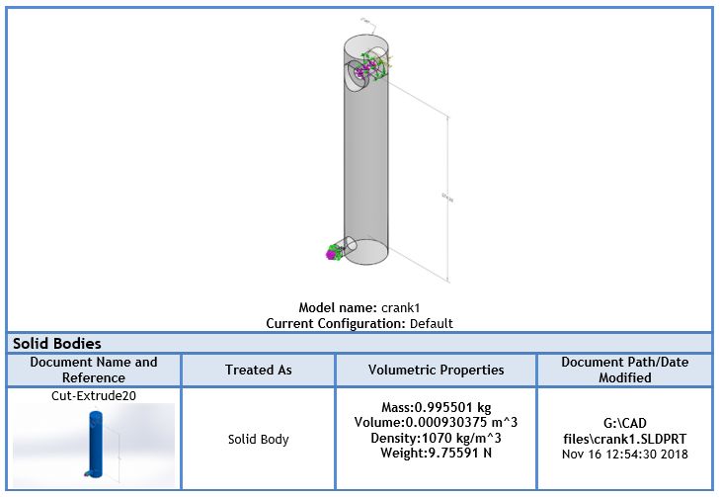

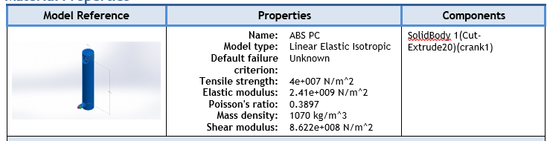

**Loads and Fixtures**

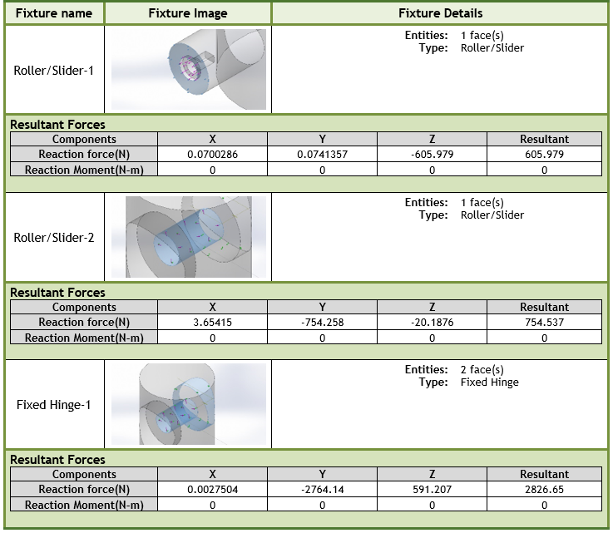

Table 2 Load Fixtures

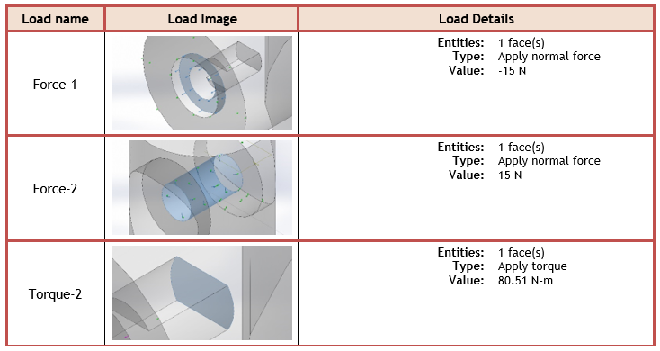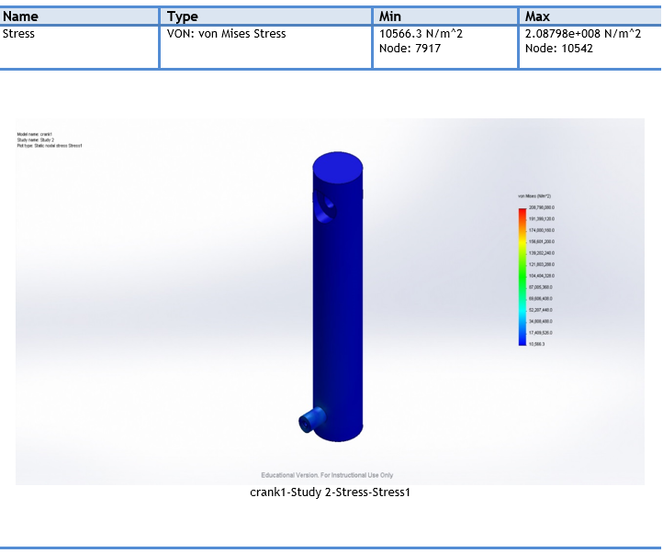

1. Figure 46 Stress of Crank Rod

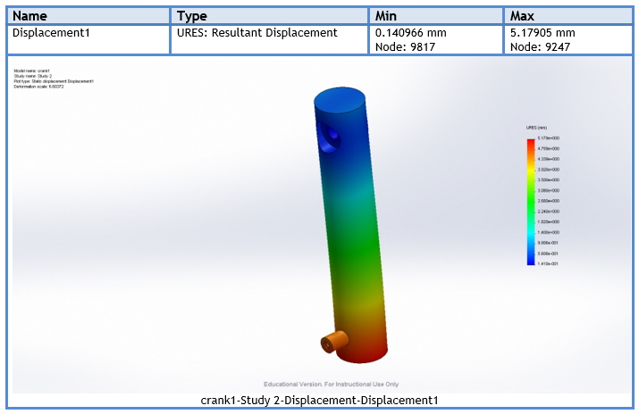

Figure 47 Displacement of Crank Rod

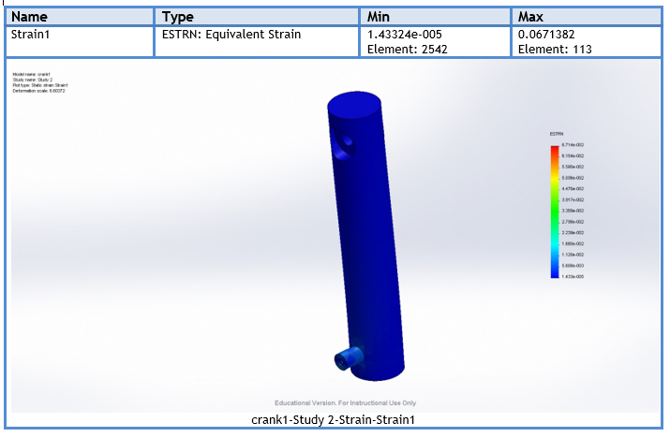

Figure 48 Stain of Crank Rod

### Stress Analysis of Conncecting Rod

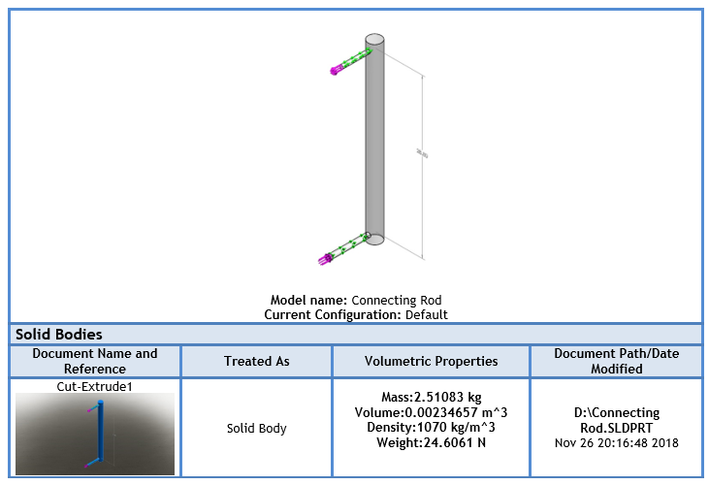

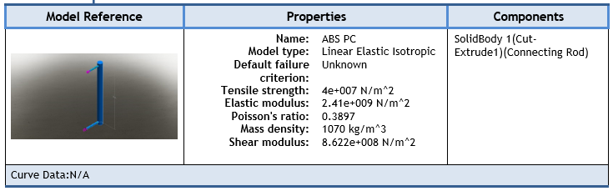

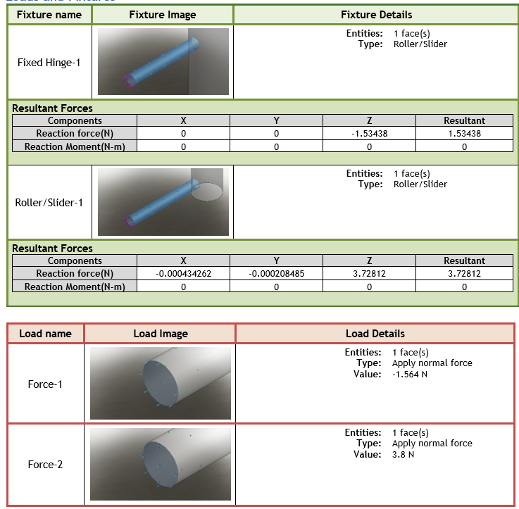

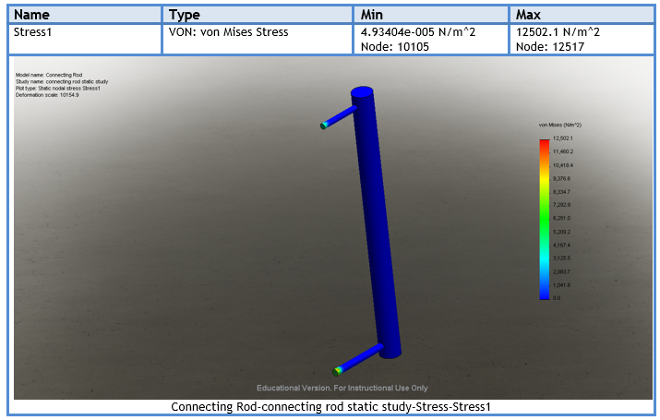

Figure 49 Stress of Connecting Rod

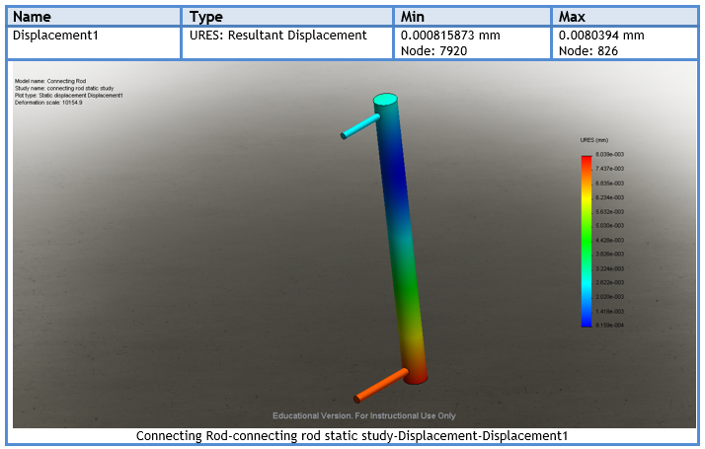

Figure 1 Displacement of Connecting Rod

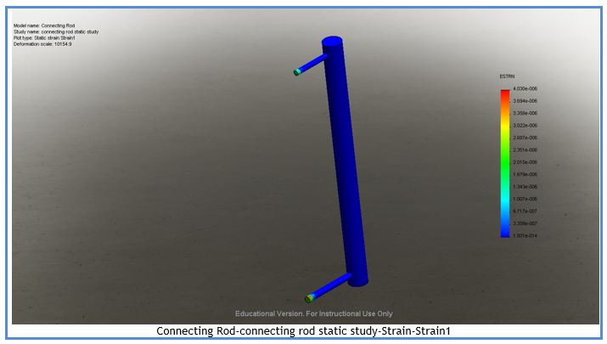

Figure 51 Strain Analysis on Connecting Rod

## Implementation of Task 7. Rover Re-Design.

After completing all the analysis and calculations for our cranks slider mechanism and verifying that it is feasible and can be implemented in real life, our next Step was to design a rover that would accommodate our mechanism. After tedious research on rover design, rover creation, and rover stability we determined that creating a rover from scratch would be beyond the range of scope for our project. If we were to try and create a rover from scratch it wouldn’t be possible to complete our project in the span of time allotted. Furthermore, we decided that the best way to go about implementing a rover into our apparatus would be to take a rover that has already been designed and make modification to tailor our specific needs. After strenuous research of different models and designs of rovers we found a model we saw fix to re-dimension and re-design in order to fit our specific needs.

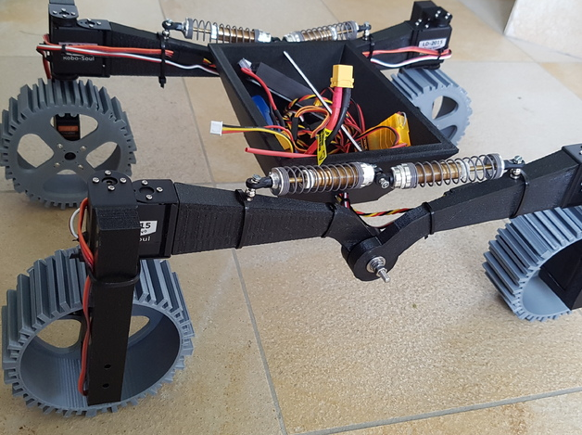

Figure 52 Original Rover Found Online

The image above shows the rover design that we found online. After taking this design and remodeling it, we built a rover that met our requirements. Some of the aspects of the rover that were changed, modified, and/ or redesigned were the shape of the arms, the legs to be able to hold the motor, the tires, the shock absorbers. Some of the parts that we keep the same were the design of the legs, the box to hold the electronics and all the electronics; Arduino 101, Adafruit Motor Shield V2, 4x standard hobby servos, 4x gear motors with wheels, 3A BEC, Switch, Fuse, 2S Lipo, 4x 100mm RC shock, 12x M3x30mm button head screw, 16 M3 nut, 4 M3 nylon nut, 16 M3 washer, 4 M4x20mm screw, 8 M4 nut, 8 M4 washer, 1 1/4″x8″ all thread bolt, 2 1/4″ nylon nut, and 6 1/4″ fender washer;

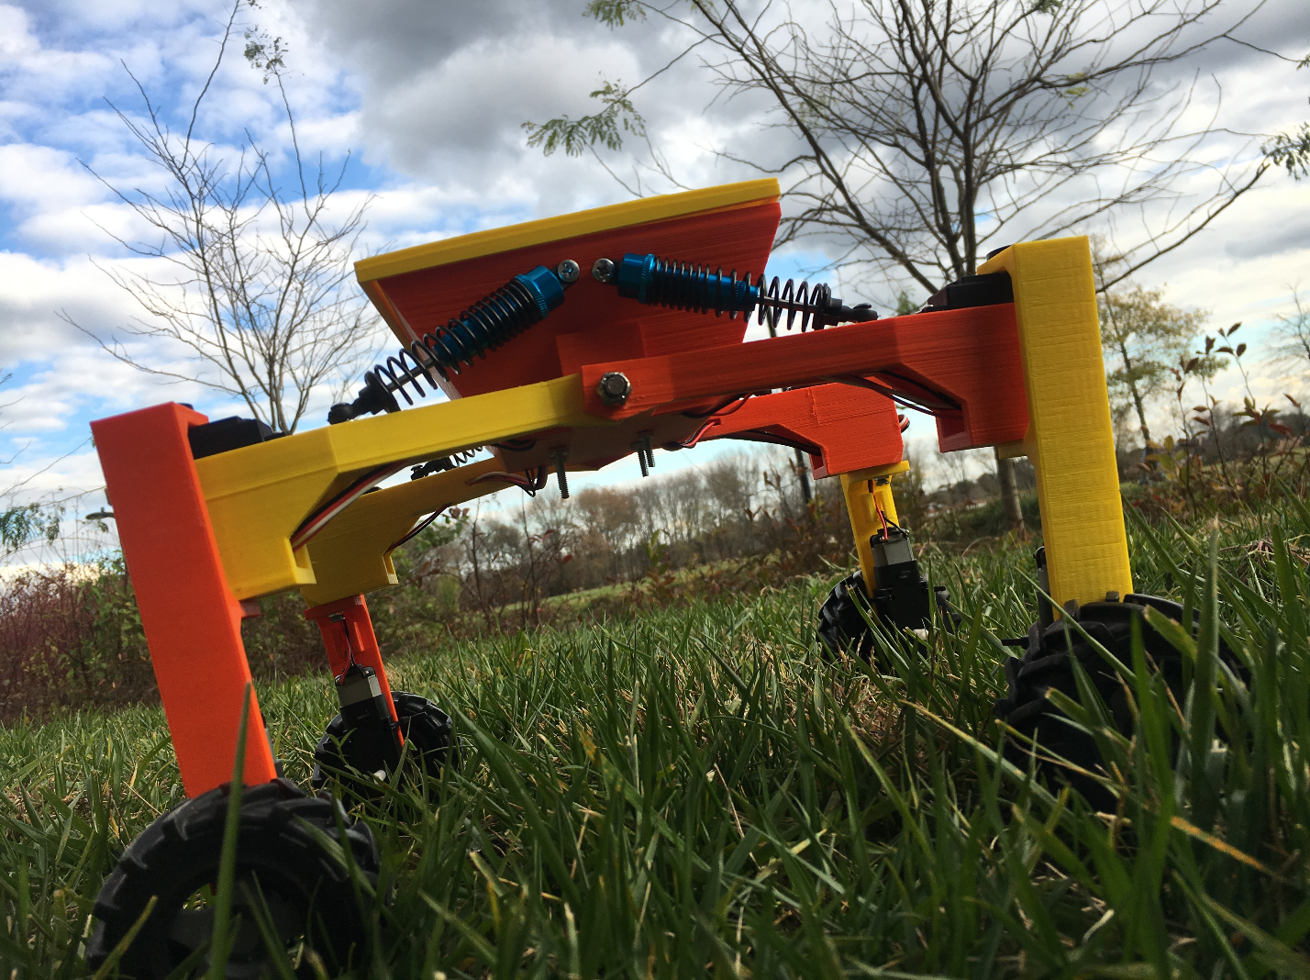

Figure 53 Final Assembled Rover Prototype

After the redesign of the rover, we 3D printed the box, the cover, the arms, and the legs to create our rover. Using the hardware listed we were able to assemble the rover with minimal complications. This image above shows the model of our rover which was 3D printed. We change the height of our rover to accommodate the crank rod so that it wouldn’t hit the ground when its rotating.

## Implementation of Task 8. Prototype.

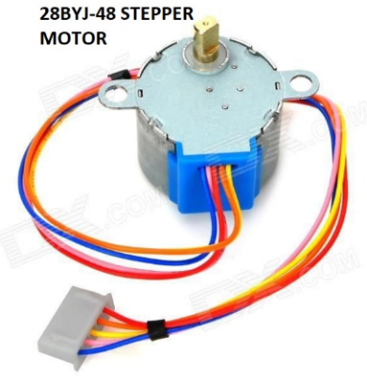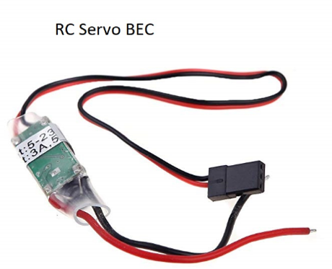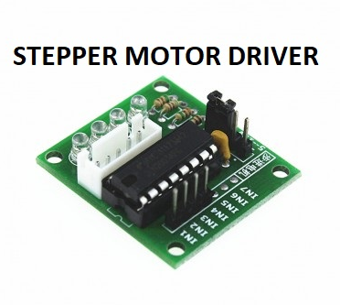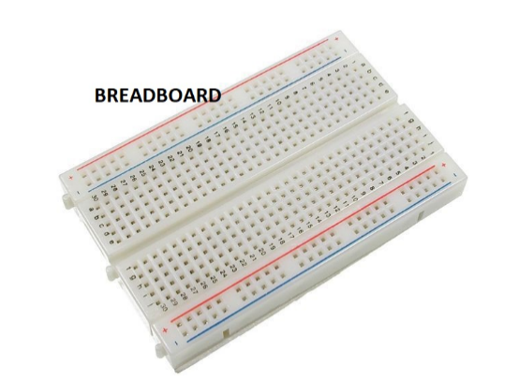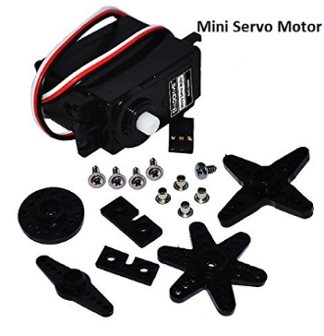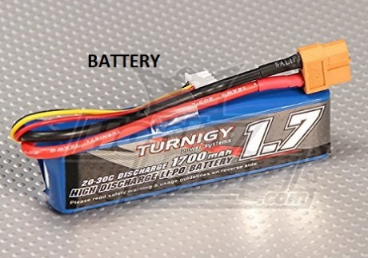

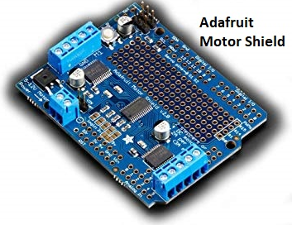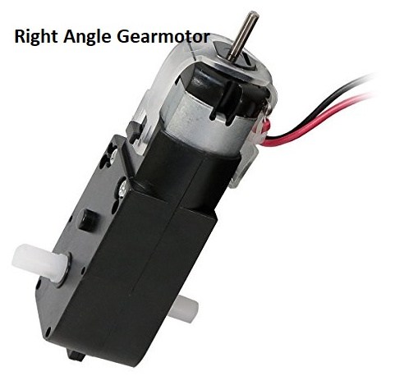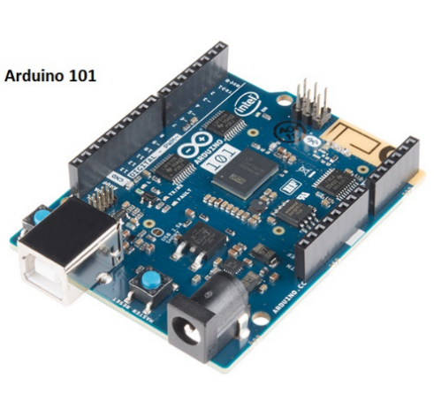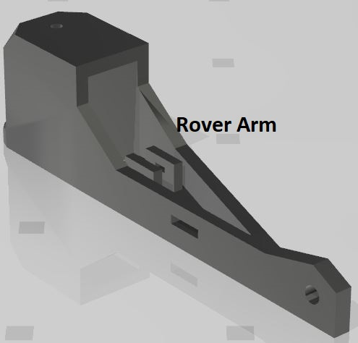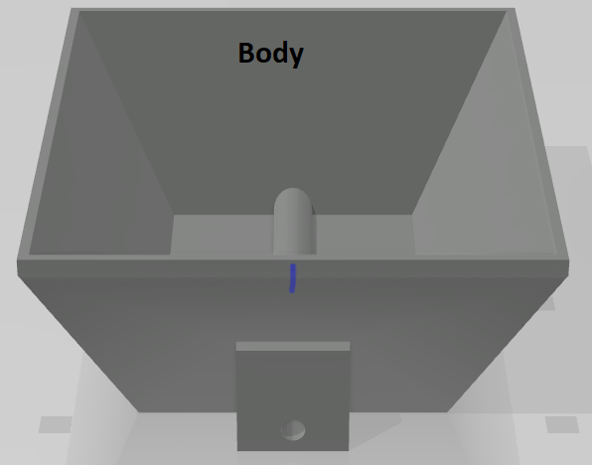

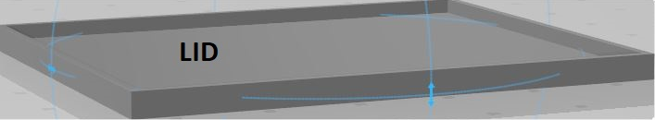

1. Conclusion.

The effects of the presence of dust were studied using falling leaves, dust, bird dropping. The dust has a major impact on the efficiency and performance of the solar panel. The reduction in the peak power generates can be up to 10 to 30%. By the observation, it is observed that power reduction due to dust accumulated on the panel. It can be improved by using the cleaning method, there is increase in power and efficiency of solar panel. This is easily maintainable and low of cost. Power consumption is also less for this process. Finally results showed that reduction in the peak power generated.

During our first semester in senior design we have made great progress in our advancement towards developing our automatic solar panel debris removing system. By the end of senior design, our goal is to have our system designed, built, and tested to clean solar panels. So far, this project has been an intense learning experience for this group. We have had to overcome many trials and tribulations to achieve success in our project. One of our biggest complications were identifying a project. A lot of time was spent, during the first half of the semester, trying to identify a project suitable for this class. Since so much time was spent identifying a project, it left a lot less time in the semester to work on the project. This project showed us that anything is possible with a good plan, guidance and challenging work.

In the upcoming semester, our engineering team has mapped out what our next steps should be in order to complete our project in entirety. The next step in our main tasks include power calculations for the system, rover stability, prototyping the system, and delivery. This experience has really shaped us as engineers, helping us grow mentally and preparing both of us for very successful careers in the engineering field. We are happy to be experiencing this senior design class with students that really help drive our passion for engineering. We are very egger to continue our next steps working on our project and have high hopes for the progress to come soon.

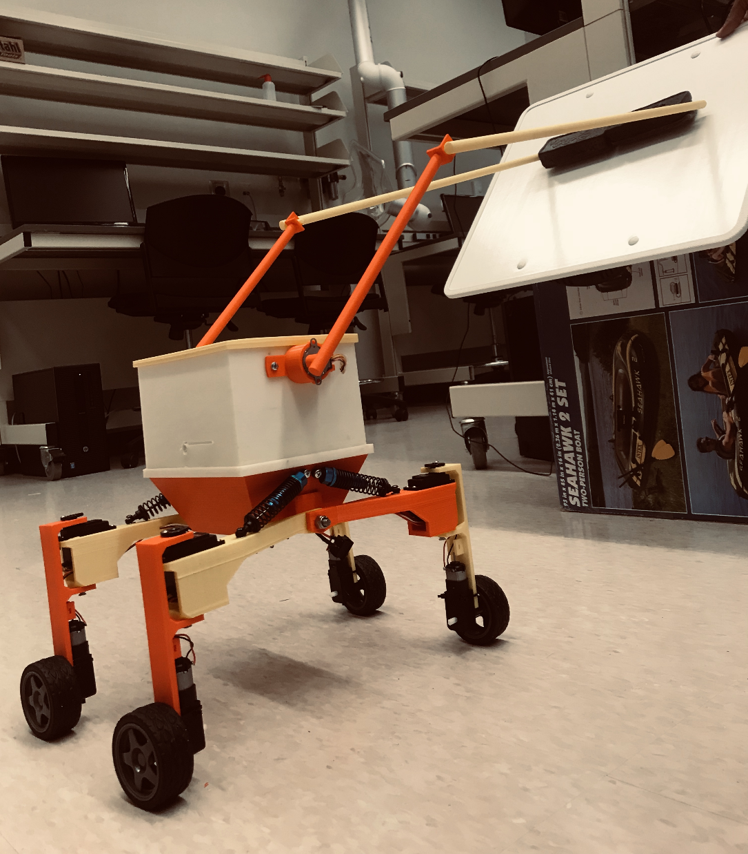

Acknowledgement

Dr. Payam Matin – Mechanical Engineering Associate Professor

Alvernon Walker, Ph.D.– Associate Professor, Electrical Engineering

Mr. Joel Tomlinson. – Lecturer/Laboratory Technician for the Electrical/Electronic Engineering

Mamoun Y. Ibrahim, M.S.– Laboratory Manager

Justin Derickson – Electrical Engineering Student

​Habilou Ouro-Koura.– Mechanical Engineering Student

Appendix

1. Component Specs for Machine
2. Specs of Arduino 101

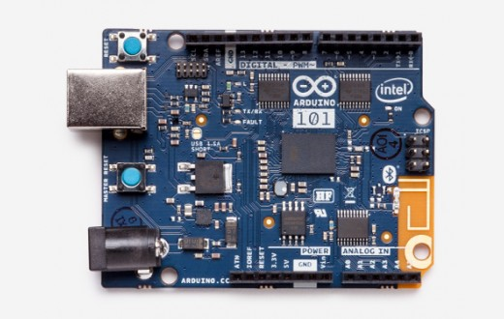

Microcontroller: Intel Curie

Operating Voltage: 3.3V (5V tolerant I/O)

Input Voltage: 7-12V

Input Voltage (limit): 7-17V

Digital I/O Pins: 14 (of which 4 provide PWM output)

PWM Digital I/O Pins 4

Analog Input Pins: 6

DC Current per I/O Pin: 20 mA

Flash Memory : 196 kB

SRAM : 24 kB

Clock Speed: 32MHz

LED_BUILTIN: 13

Features: Bluetooth LE, 6-axis accelerometer/gyro

Length: 68.6 mm

Width: 53.4 mm

Weight: 34 gr.

1. Specs of Adafruit Motor Shield

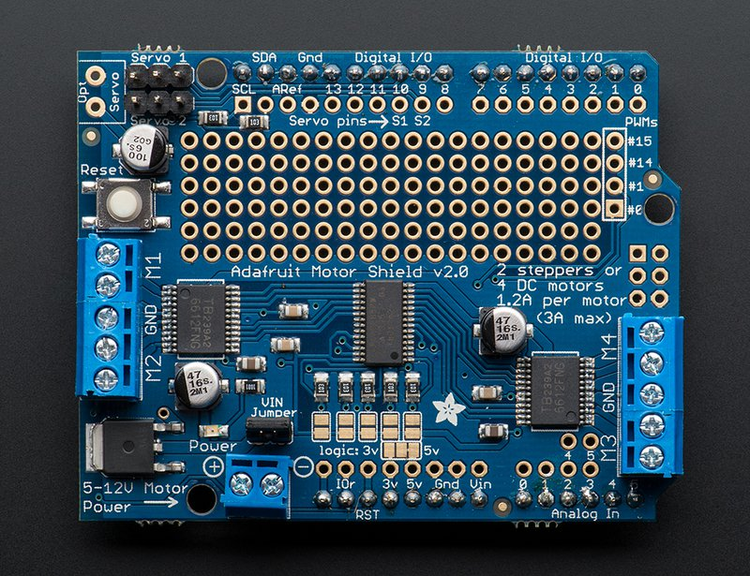

Dimensions, assembled: 70mm x 55mm x 10mm 2.7"x2.1"x0.4"

This board/chip uses I2C 7-bit addresses between 0x60-0x80, selectable with jumpers

2 connections for 5V 'hobby' servos connected to the Arduino's high-resolution dedicated timer - no jitter!

4 H-Bridges: TB6612 chipset provides 1.2A per bridge (3A for brief 20ms peaks) with thermal shutdown protection, internal kickback protection diodes. Can run motors on 4.5VDC to 13.5VDC.

Up to 4 bi-directional DC motors with individual 8-bit speed selection (so, about 0.5% resolution)

Up to 2 stepper motors (unipolar or bipolar) with single coil, double coil, interleaved or micro-stepping.

Motors automatically disabled on power-up

Big terminal block connectors to easily hook up wires (18-26AWG) and power

1. Specs of Right Angle Motor

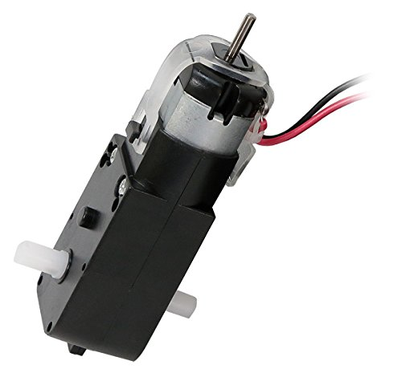

Quantity: 4

 No Load Speed: 140RPM

No Load Current: 190mA

Max. Load Current: 250mA

Torque: 800 gf-cm (11.11 oz-in)

1. Specs of Hobby Servos

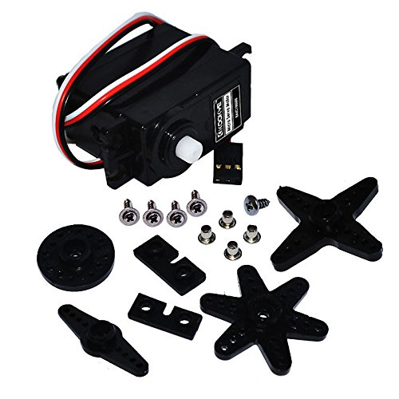

Quantity: #1

Torque: 5.5kg/cm (at 4.8V)   
Speed: 0.22sec/60°(at 4.8V)   
Working voltage: 4.8v-6v DC   
Temperature: 0℃-60℃   
Current: < 1000mA   
Weight: 38g

1. Specs for Voltage Regulator

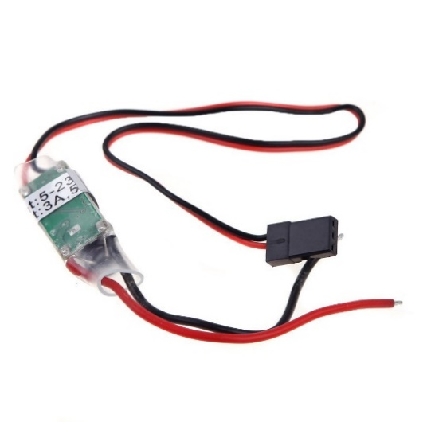

3A BEC

Quantity: 1

Output Voltage: 5V / 3A

Size: 43 x 17 x 7mm

Weight: 11g

Input: 5.5V-26V

frequency: 300KHz

1. Specs for Switch

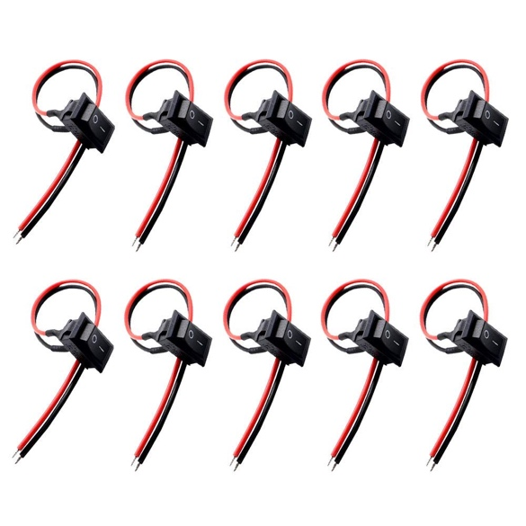

Voltage & Current: AC 250V 6A/125V 10A

Overall Size: 2.1 x 1.5cm/ 0.83" x 0.59"(L*W)

Mount Size: 1.9 x 1.2cm / 0.75" x 0.47"(L*W)

Cable diameter: 2mm

Cable Length: 18cm/ 7.1"

Body Color: Black,

Material: Plastic, Metal

1. Specs for Fuse

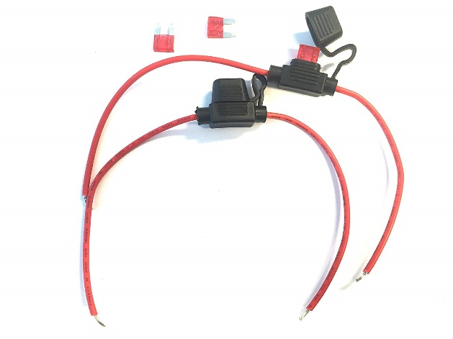

2 Inline Fuse Cable Holders on Precut Wires, Ready Solder

3x Blade Fuses for auto use 12V 24V

Snap on holder is secure and waterproof

#16 Gauge wires

1. Specs for Lipo Battery

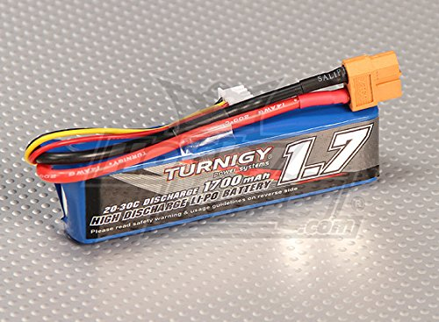

Type: Turnigy Heavy Duty 2000mAh 6S 60C Lipo Pack

Weight: 2.2lbs

Capacity: 5000mAh

# of Batteries: 1

1. Hardware
   * 4 x 100mm RC shock
   * 12x M3x30mm button head screw
   * 16 M3 nut
   * 4 M3 nylon nut
   * 16 M3 washer
   * 4 M4x20mm screw
   * 8 M4 nut
   * 8 M4 washer
   * 1 ¼ 8 inch all thread bolt
   * 2 ¼ nylon nut
   * 6 ¼ “ fender washer
2. Source Code.
3. Arduino Source Code of Rover

#define BLYNK_PRINT Serial

#include <BlynkSimpleCurieBLE.h>

#include <CurieBLE.h>

#include <Wire.h>

#include <Adafruit_MotorShield.h>

#include "utility/Adafruit_MS_PWMServoDriver.h"

#include <Servo.h>

//Blynk

char auth[] = "71054d5189654761a50d91f622ad4a7f"; // You should get Auth Token in the Blynk App.

BLEPeripheral blePeripheral;

//Adafruit Motor Shield

Adafruit_MotorShield AFMS = Adafruit_MotorShield(); // Create the motor shield object with the default I2C address

Adafruit_DCMotor *motor1 = AFMS.getMotor(1); // Select which 'port' M1, M2, M3 or M4.

Adafruit_DCMotor *motor2 = AFMS.getMotor(2);

Adafruit_DCMotor *motor3 = AFMS.getMotor(3);

Adafruit_DCMotor *motor4 = AFMS.getMotor(4);

//Servo

Servo servo1; // create servo object to control a servo

Servo servo2;

Servo servo3;

Servo servo4;

int pos1 = 0; // variable to store the servo position

int pos2 = 0;

int pos3 = 0;

int pos4 = 0;

int vDirection = 1;

int vConfiguration = 1;

int vTurn = 0;

int vSpeed = 0;

//######### SETUP ######################################

void setup() {

Serial.begin(9600);

delay(1000);

//Blynk BLE The name your bluetooth service will show up as, customize this if you have multiple devices

blePeripheral.setLocalName("TMMarsRover");

blePeripheral.setDeviceName("TMMarsRover");

blePeripheral.setAppearance(384);

Blynk.begin( blePeripheral, auth);

blePeripheral.begin();

Serial.println("Waiting for connections...");

Serial.println("Adafruit Motorshield v2 - DC Motor");

//Adafruit Motor Shield

AFMS.begin(); // create with the default frequency 1.6KHz

motor1->setSpeed(255); // Set the speed to start, from 0 (off) to 255 (max speed)

motor2->setSpeed(255);

motor3->setSpeed(255);

motor4->setSpeed(255);

//Servo

servo1.attach(3); // attaches the servo on pin 3 to the servo object

servo2.attach(5);

servo3.attach(6);

servo4.attach(9);

}

//########## LOOP ######################################

void loop() {

Blynk.run();

blePeripheral.poll();

}

//######### Subrutines ################################

// This function will set the speed

BLYNK_WRITE(V0)

{

vSpeed = param.asInt(); // assigning incoming value from pin V1 to a variable

motor1->setSpeed(vSpeed);

motor2->setSpeed(vSpeed);

motor3->setSpeed(vSpeed);

motor4->setSpeed(vSpeed);

Serial.print("V0... vSpeed: ");

Serial.print(vSpeed);

Serial.print(" vDirection: ");

Serial.print(vDirection);

Serial.print(" vTurn: ");

Serial.print(vTurn);

Serial.print(" vConfiguration: ");

Serial.println(vConfiguration);

//Serial.println("V0... vSpeed: " & vSpeed & " vDirection: " + vDirection + " vTurn: " + vTurn + " vConfiguration: " + vConfiguration);

motorStuff();

}

// Direction

BLYNK_WRITE(V1)

{

int pinValue = param.asInt(); // assigning incoming value from pin V1 to a variable

if(pinValue == 1) {

vDirection = 1;

}

if(pinValue == 0) {

vDirection = 0;

}

motorStuff();

Serial.print(" vDirection: ");

Serial.println(vDirection);

}

// Configuration

BLYNK_WRITE(V2)

{

int pinValue = param.asInt(); // assigning incoming value from pin V1 to a variable

if(pinValue == 0) {

vConfiguration = 0;

servoPosNormal();

}

if(pinValue == 1) {

vConfiguration = 1;

servoPosStrafe();

}

motorStuff();

Serial.print(" vConfiguration: ");

Serial.println(vConfiguration);

}

// Turn

BLYNK_WRITE(V3)

{

int pinValue = param.asInt(); // assigning incoming value from pin V1 to a variable

if(pinValue == 1) {

servoPosTurn();

vTurn = 1;

}

if(pinValue == 0) {

if(vConfiguration == 0) {

servoPosNormal();

}

else{

servoPosStrafe();

}

vTurn = 0;

}

motorStuff();

Serial.print(" vTurn: ");

Serial.println(vTurn);

}

// This function will set the speed

BLYNK_WRITE(V4)

{

int vStop = param.asInt(); // assigning incoming value from pin V1 to a variable

if(vStop == 1) {

motor1->run(RELEASE);

motor2->run(RELEASE);

motor3->run(RELEASE);

motor4->run(RELEASE);

}

}

void motorStuff() {

if(vSpeed == 0) {

motor1->run(RELEASE);

motor2->run(RELEASE);

motor3->run(RELEASE);

motor4->run(RELEASE);

}

else if(vTurn == 1) {

if(vDirection == 1) {

motor1->run(FORWARD);

motor2->run(BACKWARD);

motor3->run(FORWARD);

motor4->run(BACKWARD);

}

if(vDirection == 0) {

motor1->run(BACKWARD);

motor2->run(FORWARD);

motor3->run(BACKWARD);

motor4->run(FORWARD);

}

}

else if(vConfiguration == 1) {

if(vDirection == 1) {

motor1->run(FORWARD);

motor2->run(BACKWARD);

motor3->run(BACKWARD);

motor4->run(FORWARD);

}

if(vDirection == 0) {

motor1->run(BACKWARD);

motor2->run(FORWARD);

motor3->run(FORWARD);

motor4->run(BACKWARD);

}

}

else if(vConfiguration == 0) {

if(vDirection == 1) {

motor1->run(FORWARD);

motor2->run(FORWARD);

motor3->run(FORWARD);

motor4->run(FORWARD);

}

if(vDirection == 0) {

motor1->run(BACKWARD);

motor2->run(BACKWARD);

motor3->run(BACKWARD);

motor4->run(BACKWARD);

}

}

}

void servoPosNormal() {

servo1.write(178);

servo2.write(0);

servo3.write(7);

servo4.write(175);

}

void servoPosStrafe() {

servo1.write(75);

servo2.write(100);

servo3.write(108);

servo4.write(70);

}

void servoPosTurn() {

servo1.write(115);

servo2.write(65);

servo3.write(65);

servo4.write(115);

}

//Individual servo functions for calibration

// Servo1

BLYNK_WRITE(V10)

{

int pinValue = param.asInt(); // assigning incoming value from pin V1 to a variable

servo1.write(pinValue);

}

// Servo2

BLYNK_WRITE(V11)

{

int pinValue = param.asInt(); // assigning incoming value from pin V1 to a variable

servo2.write(pinValue);

}

// Servo3

BLYNK_WRITE(V12)

{

int pinValue = param.asInt(); // assigning incoming value from pin V1 to a variable

servo3.write(pinValue);

}

// Servo4

BLYNK_WRITE(V13)

{

int pinValue = param.asInt(); // assigning incoming value from pin V1 to a variable

servo4.write(pinValue);

}

1. Arduino Source Code of Crank Mechanism

int Pin0 = 10;

int Pin1 = 11;

int Pin2 = 12;

int Pin3 = 13;

int Pin4 = 4;

int Pin5 = 5;

int Pin6 = 6;

int Pin7 = 7;

int _step = 0;

boolean dir = false;// gre

void setup()

{

pinMode(Pin0, OUTPUT);

pinMode(Pin1, OUTPUT);

pinMode(Pin2, OUTPUT);

pinMode(Pin3, OUTPUT);

}

void loop()

{

switch(_step){

case 0:

digitalWrite(Pin0, LOW);

digitalWrite(Pin1, LOW);

digitalWrite(Pin2, LOW);

digitalWrite(Pin3, HIGH);

digitalWrite(Pin4, HIGH);

digitalWrite(Pin5, LOW);

digitalWrite(Pin6, LOW);

digitalWrite(Pin7, HIGH);

break;

case 1:

digitalWrite(Pin0, LOW);

digitalWrite(Pin1, LOW);

digitalWrite(Pin2, HIGH);

digitalWrite(Pin3, HIGH);

digitalWrite(Pin4, HIGH);

digitalWrite(Pin5, LOW);

digitalWrite(Pin6, LOW);

digitalWrite(Pin7, LOW);

break;

case 2:

digitalWrite(Pin0, LOW);

digitalWrite(Pin1, LOW);

digitalWrite(Pin2, HIGH);

digitalWrite(Pin3, LOW);

digitalWrite(Pin4, HIGH);

digitalWrite(Pin5, HIGH);

digitalWrite(Pin6, LOW);

digitalWrite(Pin7, LOW);

break;

case 3:

digitalWrite(Pin0, LOW);

digitalWrite(Pin1, HIGH);

digitalWrite(Pin2, LOW);

digitalWrite(Pin3, LOW);

digitalWrite(Pin4, LOW);

digitalWrite(Pin5, HIGH);

digitalWrite(Pin6, LOW);

digitalWrite(Pin7, LOW);

break;

case 4:

digitalWrite(Pin0, LOW);

digitalWrite(Pin1, HIGH);

digitalWrite(Pin2, LOW);

digitalWrite(Pin3, LOW);

digitalWrite(Pin4, LOW);

digitalWrite(Pin5, HIGH);

digitalWrite(Pin6, LOW);

digitalWrite(Pin7, LOW);

break;

case 5:

digitalWrite(Pin0, HIGH);

digitalWrite(Pin1, HIGH);

digitalWrite(Pin2, LOW);

digitalWrite(Pin3, LOW);

digitalWrite(Pin4, LOW);

digitalWrite(Pin5, LOW);

digitalWrite(Pin6, HIGH);

digitalWrite(Pin7, LOW);

break;

case 6:

digitalWrite(Pin0, HIGH);

digitalWrite(Pin1, LOW);

digitalWrite(Pin2, LOW);

digitalWrite(Pin3, LOW);

digitalWrite(Pin4, LOW);

digitalWrite(Pin5, LOW);

digitalWrite(Pin6, HIGH);

digitalWrite(Pin7, HIGH);

break;

case 7:

digitalWrite(Pin0, HIGH);

digitalWrite(Pin1, LOW);

digitalWrite(Pin2, LOW);

digitalWrite(Pin3, HIGH);

digitalWrite(Pin4, LOW);

digitalWrite(Pin5, LOW);

digitalWrite(Pin6, LOW);

digitalWrite(Pin7, HIGH);

break;

default:

digitalWrite(Pin0, LOW);

digitalWrite(Pin1, LOW);

digitalWrite(Pin2, LOW);

digitalWrite(Pin3, LOW);

digitalWrite(Pin4, LOW);

digitalWrite(Pin5, LOW);

digitalWrite(Pin6, LOW);

digitalWrite(Pin7, LOW);

break;

}

if(dir){

_step++;

}else{

_step--;

}

if(_step>7){

_step=0;

}

if(_step<0){

_step=7;

}

delay(1);

}

1. MATLAB Source Code for Center of Gravity

r2=10.8; % inch

r3=28.8; % inch

w2= .159155; %rps

r_cg1= 6.5079; % inch

r_cg2= 14.737; %inch

a2=0; %Angular acceleration of crank rod

TH2 = linspace(0,4*pi,100) - (pi/6) ;

TH3= asin(((9.166*sin(pi/3))-(r2*sin(TH2)))/r3) - (pi/6);

a3=((r2 .* w2.^2 .* sin(TH2))+ (r3 .* W.^2 .* sin(TH3)))./(r3 .* cos(TH3));

V_cg1= r_cg1*w2;

W=-((r2.*w2.*cos(TH2))/r3.*cos(TH3));

a_n1= V_cg1.^2./r_cg1;

a_t1=r_cg1.*a2;

ACG1=sqrt(a_t1.^2 + a_n1.^2);

w3= (-r2.*w2.*cos(TH2))./(r3.*cos(TH3));

Va=r2.*w3;

V_cg2=r_cg2.*w3;

VCG2=Va+V_cg2;

subplot(2,1,1);

plot(TH2,VCG2);

xlabel('Angle of crank rod (Theta 2)');

ylabel(' Velocity of Center of Gravity of Connecting Rod ');

title(' Graph Between angel of Crank Rod and Velocity of the Center of Gravity of Connceting Rod ');

grid

a_t2=r_cg2.*a3;

a_n2=(VCG2.^2)/r_cg2;

ACG2=sqrt(a_t2.^2 + a_n2.^2);

subplot(2,1,2);

plot(TH2,ACG2);

xlabel('Angle of crank rod (Theta 2)');

ylabel('Acceleration of Center of Gravity of Connecting Rod');

title('Graph Between angel of Crank Rod and Acceleration of the Center of Gravity of Connceting Rod ');

grid

1. MATLAB Source Code for Kinematic Analysis

7 r2=54; % inch

 r3=144;

 w2=.159155; % rps

 t=linspace(0,78.95680,100);

 TH2=w2*t;

 %TH2 = linspace(0,4*pi,100) - (pi/6) ;

 TH3= asin(((9.166*sin(pi/3))-(r2*sin(TH2)))/r3) - (pi/6);

 subplot(3,2,1)

 plot(t,TH3)

 ylabel('Angle of Connecting rod(Theta3)')

 xlabel('Time (seconds)')

 title('Graph Between Angle of Connecting Rod and Crank Rod')

grid

S=(-9.166.*cos(pi/3))+(r2.*cos(TH2))+(r3.*cos(TH3));

subplot(3,2,2)

plot(t,S)

 ylabel('Position of Brush')

 xlabel('Time (seconds)')

 title('Graph Between Position of Brush and Angle of Crank Rod')

grid

W=-((r2.*w2.*cos(TH2))/r3.*cos(TH3));

subplot(3,2,3)

plot(t,W)

grid

 ylabel('Angular Velocity of Connecting Rod')

 xlabel('Time (seconds)')

 title('Graph Between Angle of crank rod (Theta 2) and Angular Velocity of Connecting Rod')

 Vb= (-r2.*w2.*sin(TH2))-r3.*W;

 subplot(3,2,4)

plot(t,Vb)

grid

 ylabel(' Velocity of Brush')

 xlabel('Time (seconds)')

 title('Graph Between Angle of crank rod (Theta 2) and Velocity of Brush')

 Acc= ((r2 .* w2.^2 .* sin(TH2))+ (r3 .* W.^2 .* sin(TH3)))./(r3 .* cos(TH3));

 subplot(3,2,5)

 plot(t,Acc)

 grid

 ylabel(' Angular Acceleration of Connecting Rod')

 xlabel('Time (seconds)')

 title('Graph Between Angle of crank rod (Theta 2) and Angular Acceleration of Connecting Rod')

 AX= (-r2 * w2.^2 .* cos(TH2))- (r3 * W.^2 .* cos(TH3))- (r3 .* Acc .* sin(TH3));

 subplot(3,2,6)

 plot(t,AX)

grid

 ylabel(' Acceleration of Brush')

 xlabel('Time (seconds)')

 title('Graph Between Angle of crank rod (Theta 2) and Acceleration of Brush')

REFERENCES

[1] *Abaqus/CAE User's Guide (6.13)*, license.mech.northwestern.edu:2080/v6.13/books/usi/default.htm?startat=pt05ch44s02hlb10.html.

[2] Kövecses, József. “Dynamics of Mechanical Systems and the Generalized Free-Body Diagram-Part II: Imposition of Constraints.” *Journal of Applied Mechanics*, American Society of Mechanical Engineers, 1 Nov. 2008, appliedmechanics.asmedigitalcollection.asme.org/article.aspx?articleid=1474387.

[3] Mabie, H.H., and Reinholtz, C.F., Mechanisms and Dynamics of Machinery (4th Ed.), John Wiley & Sons. 1987.

[4] Logan, Daryl l. *A First Course in Finite Element Method*. 4th ed.

[5] Norton, Robert L. *Machine Design: an Integrated Approach*. Prentice Hall, 2014.

[6] “5.5. Illustrative Problems.” *StudFiles*, studfiles.net/preview/4494350/page:4/.